Getting Started with Git

Get Up and Running with Git

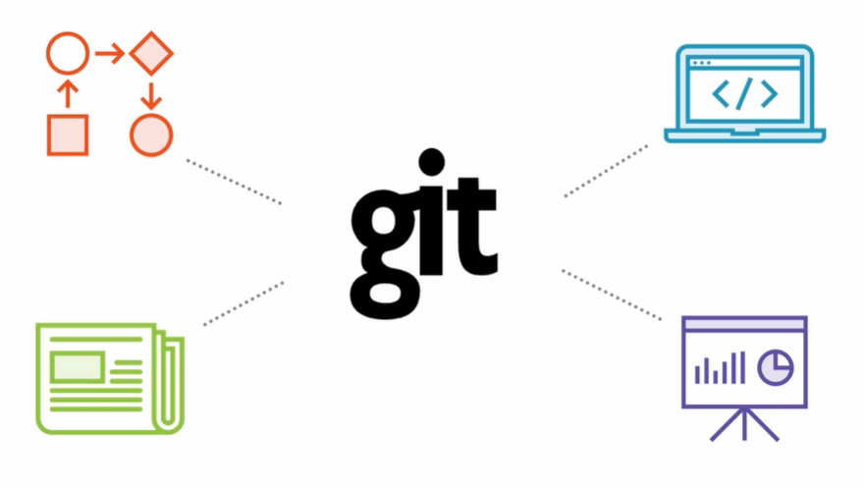

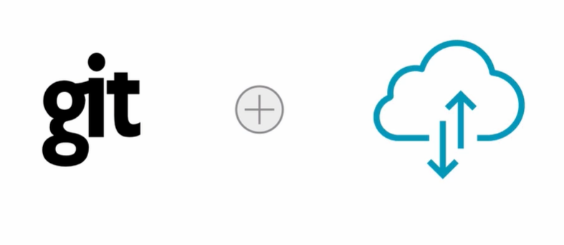

What is **Git? A version control system**:

-software designed to record changed made to files over time

-ability to revert back to previous file version or project version

-compare changes made to files from one version to another

-version control any plain text file, not just source code

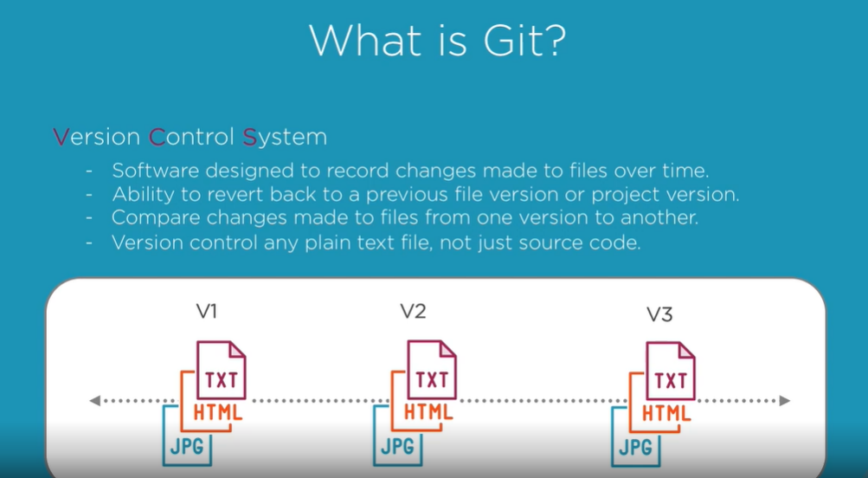

Coffee Shop Analogy:

Understanding how Git manages data is the most important thing to remember about Git. Everything Git does is based upon how it manages data.

Our story starts with Steve, Steve is a well-known owner of a coffee shop downtown, called Wired Brain Coffee. Steve manages all operations and even developed most of shopes recipes himself. In order to keep the popularity of his shop, he constantly tries out new ideas, by altering existing recipes and changing out certain technique and ingredients that are use. He wants to keep existing recipes but also keep track of these changes in case he decides to make a change the new menu item of the month.

Currently Steve stores these recipe files on his computer. And when he wants to make a change, he alters the actual file and resaves it with a different recipe name. His approach to saving files is common and simple. But as we learned earlier, it’s incredibly error prone as Steve has made several mistakes and has accidentally resaved over files he didn’t intend to. Another issue Steve has encountered is the accessibilities of these files. Steve occasionally works on his home computer, as well as other devices when not as his work computer and this has made it difficult to keep everything up to date on the changes Steve is making across these multiple devices.

And Steve’s whole approach is very manual and time-consuming process, and Steve is looking for a better way to add both clarity and simplicity to this process. With this analogy, let’s see how Git and Steve can harness it’s power to improve the way he manages his files within his Wired Brain Coffee Project.

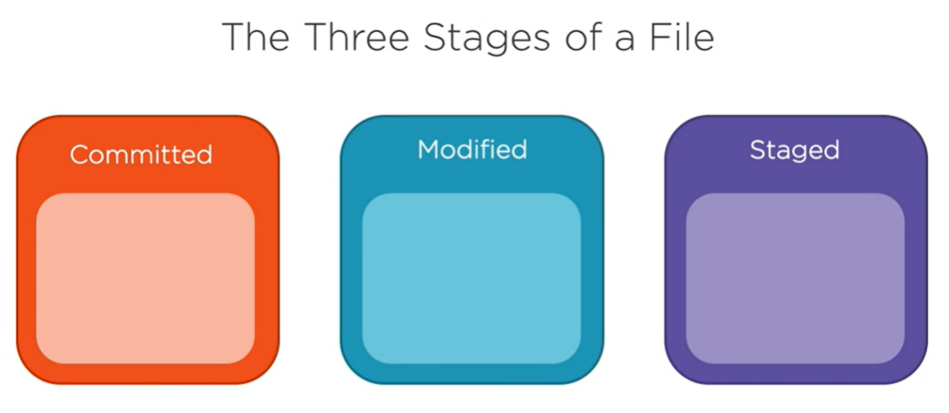

**Git has 3 Main Stages a file can occupy: Committed, modified, and staged.**

-A file that resides in the **committed stage** means that the data in this file is safely stored in Steve’s local database with that project. When Steve makes changes to his recipe file, the status of the file moves from committed, or unmodified, to modified.

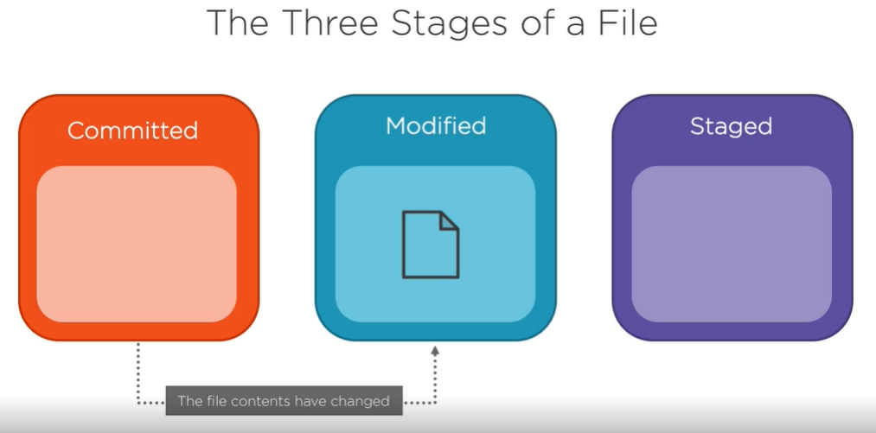

-This **modified state** means that the file has been altered from the last committed version that is stored in the local database. Basically, this state just means that Steve has introduced new changes to the recipe file but hasn’t committed them yet. You can think of this state as a work in progress where more changes can be made to that file.

-When Steve has finished the changes he wants to make to a file, the file then moves to the **staged state**.

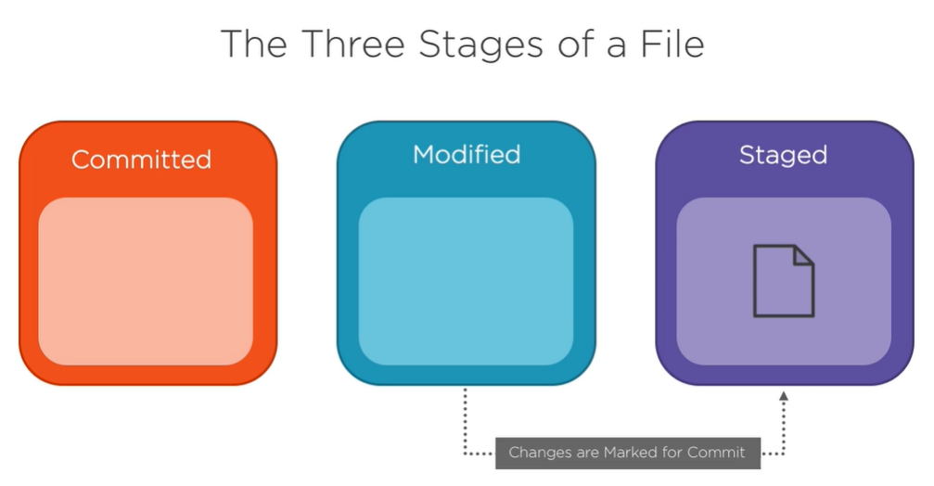

This means that Steve wants to make the changes made to that file during the modified state and then commit them to his local database to be in his next commit snapshot.

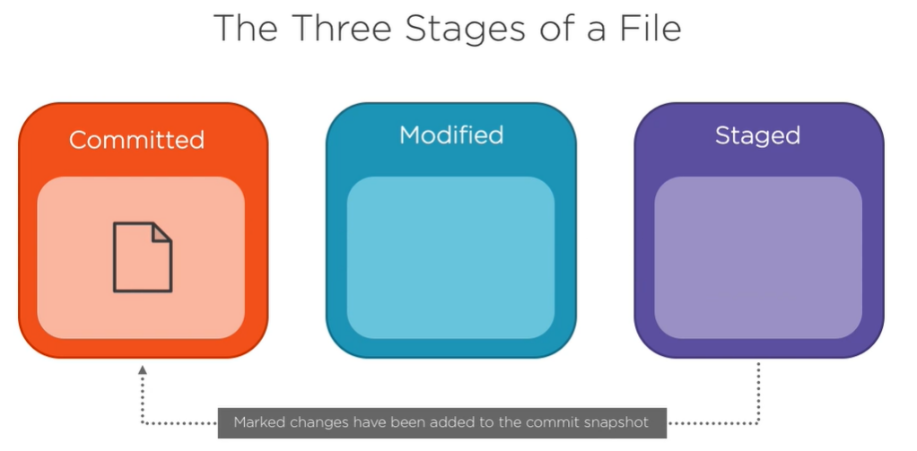

It is important to note that these three stages are applied to files in his project that being tracked by Git. In other words, these stages only apply to files that were in the project’s last commit snapshot. A file can be untracked. Untracked files are any files added to the project since the last snapshot that Git hasn’t been tracking. To start tracking and untracked file, Steve can simply add it to his Git project, and then Git places that file in the staged state and it will be added in the next commit snapshot.

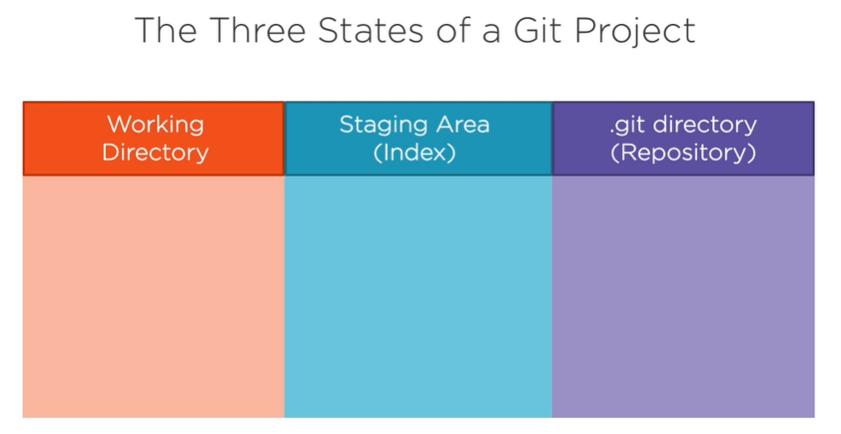

Similar to how a file can reside in three different states, Steve’s Git project is made up of 3 main parts. We start with the .git directory, also known as a repository. This is the origin of Steve’s project’s data and is what pulled down from the remote server which in Steve’s case is currently being stored on his local computer. There is where Git stores the metadata and object database for his project.

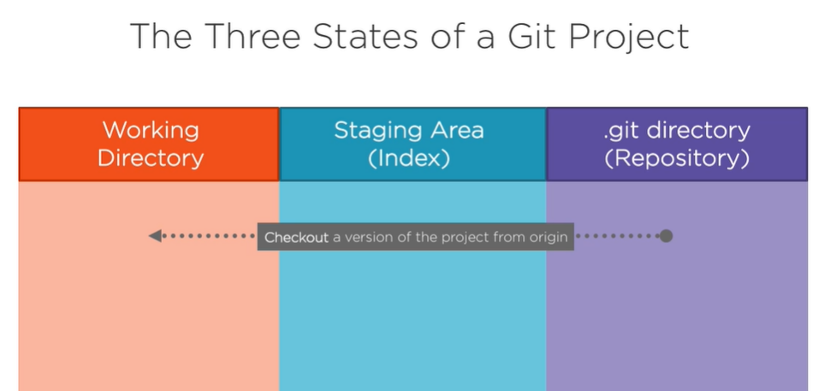

Next we have the working directory.

This is the single copy, as known as the checkout of one version of the project. These files are pulled from Steve’s local compressed database in the **.git directory** and placed in the working directory that he can then modify. The staging area is also known as the index. This is an area that sits between his working directory and the .git directory. Steve can use the staging area to build up a change or set of changes that he wants to commit by taking a snapshot of his project with those changes in places, when he creates a commits what is committed is only what is currently in the staging area, not what is what is working directory. 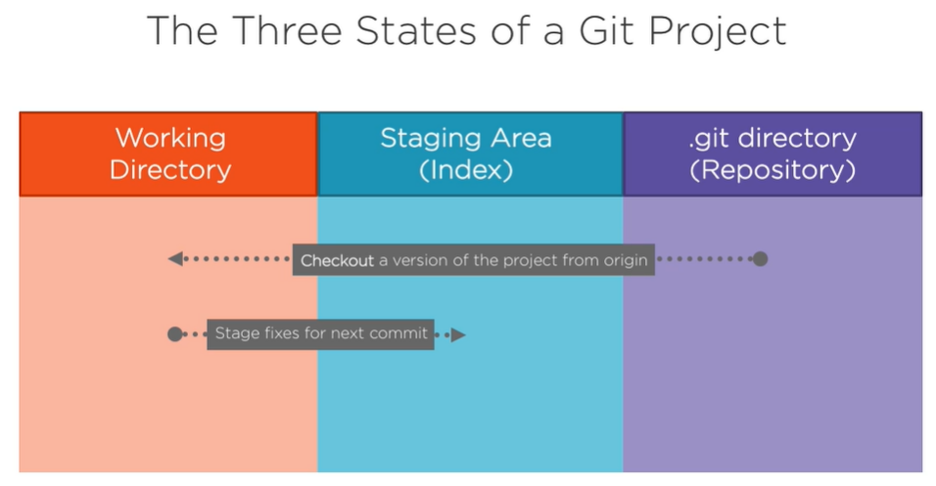

This gives Steve the freedom to modify several files, but only commit the changes of a file or files that he wants.

The uncommitted changes remains in his working directory until he decides to commit them or stash them away for future use.

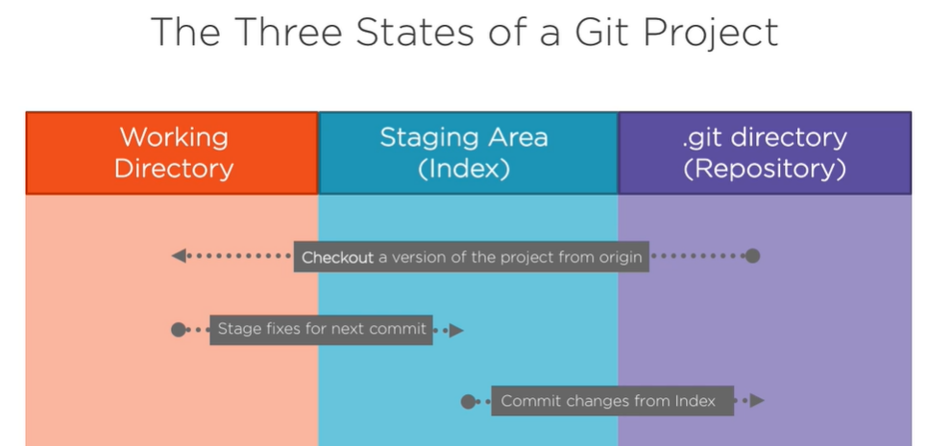

After he commits his changes, he then pushes his commits up to the .git directory to update the origin data of his project.

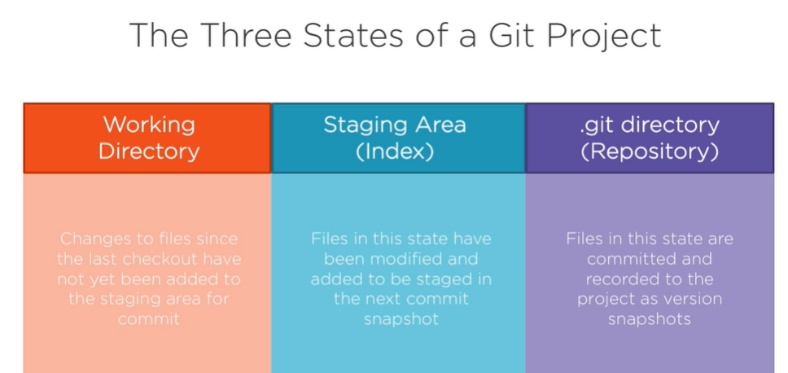

So, in short, if a file version is in the .git directory, it's committed and recorded in that project's repository; if a file is modified and has been added to the staging area, it's staged; and if a file was modified since the last checkout of that file from the .git directory, but has not been added to the staging area, it's modified.

**Using the Command Line**

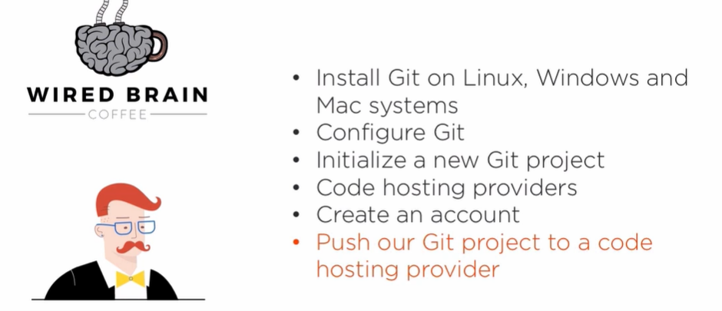

If you recall from earlier, steve, who is the owner of Wired Brain Coffee, is looking for a better way to manage his recipe files instead of copying the existing files and saving them under different file names to keep track of his changes. Since Steve has read about the powers of Git, he is excited to finally start managing his files efficiently by adding Git to his existing project. So let's continue Steve's story and see how he uses Git to manage his project moving forward. First, we're going to cover the process of installing Git on Linux, Windows, and Mac systems and learn how to configure Git, regardless of which system you're using. We'll then learn how to initialize or start a new Git project and then be introduced to a code hosting provider and learn how to start using it by first creating an account to host out Git project. We'll then learn how to push our local project to the code hosting provider so we can then have access to our project on our multiple devices. So let's get started.

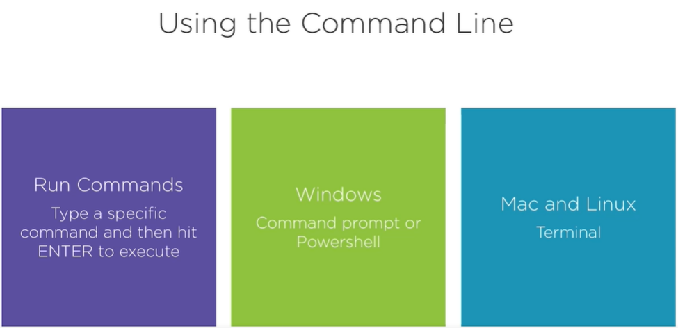

Before we install Git, we need to become somewhat familiar with the command line. Now, if you've never used the command line before, this can seem a little daunting. But here, we'll cover a few simple commands that will give you the confidence to begin your next Git project, as well as start you on a path to continue learning. As the name implies, the command line is used to run commands by typing specific commands and then hitting Enter to execute that command. It's important to note that many of these commands are dependent on your current directory location, so you'll want to make sure that you're in your project's directory before running your commands. Now, for Windows users, you can open up the Command Prompt or PowerShell, and for Linux or Mac users, which is what Steve will be using in this course, you can open up a terminal, which comes preinstalled with every Mac OS X system, and can be found in the Applications folder inside of the utilities subfolder. Throughout this course, we'll be using a few terminal commands to perform some actions. There are some slight differences with these commands depending on what system you're using, but the result will be the same.

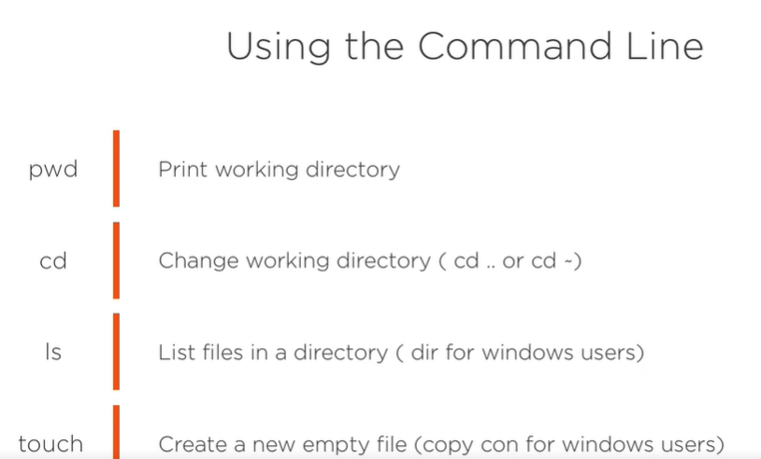

The first command to know is the **pwd command**. **Pwd**, which stands for print working directory, just returns your current folder path location. This is a simple, yet useful command that simply lets you know where you are at currently inside terminal. Now that we know where we are, you can use another command to change your location. The cd command, which stands for change directory, will move us into another directory. To go one directory upwards in the current folder path, we can type **cd dot dot**. You can also cd into a subfolder by typing cd and then the name of the subfolder. If you want to jump to the beginning home folder, you can type cd tilde. Now, there are several other options on how to use the cd command, but for this course, we will mostly be using the **cd ..** command to go up one directory. Another useful command is how to list the files in the directory.

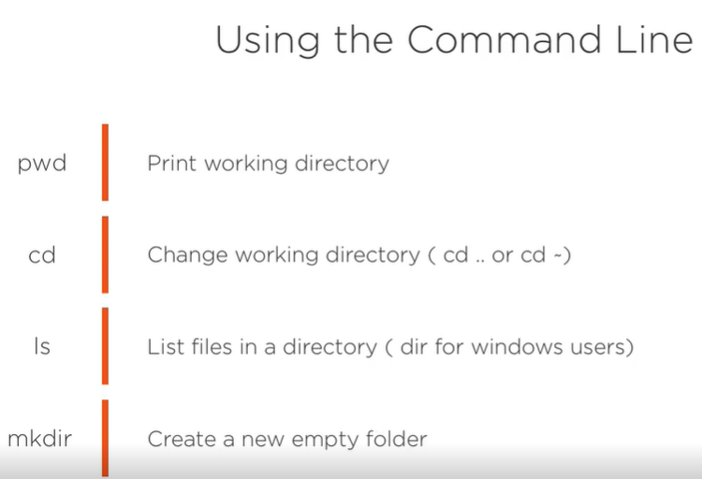

For Linux and Mac users, we type ls, and for Windows users, you can type d‑i‑r, or dir. To create a new empty file, we can use the command touch for Mac and Linux users and the command copy con for Windows users, and you can create a new empty folder by using the **mkdir** command. As mentioned, these are just a few simple commands that you can use in the command line. Now there are many, many other commands and even other options to use with these few commands that we just learned, but for now, we'll stick to just these few commands.

**Install Git**

Now that we've learned some terminal commands, we now need to install Git on our machine. Regardless of the system you're using, this is a pretty easy and straightforward process that is basically a one‑line command or a click on a downloadable link. If you're running Linux, Git is easiest to download using the package manager for your Linux distribution. Debian users can use sudo apt‑get install git, where Fedora users can use sudo yum install git. If using Windows, there are several different programs that you can use to install Git, but the easiest that I've found is that git‑scm.com/download/win. This automatically starts the download of the Git installer, and this installation also installs a command‑line tool called Git BASH that will give you a more Linux feel on a Window system to perform the Git commands. For Mac users, you can use the same URL that was used to download Git for Windows, but instead of /win, type /mac. Like the Windows installer, this will automatically download the latest version of Git. Mac users can also use Homebrew, which is a popular free and open‑source software package manager that simplifies the installation of software on macOS. If already installed, you can use Homebrew to download a number of different software packages. But to download Git using Homebrew, just type brew install git in the terminal window. Now, since Steve is on a Mac computer, we'll be using the git ‑scm.com/download/mac to download Git.

**Configure Git**

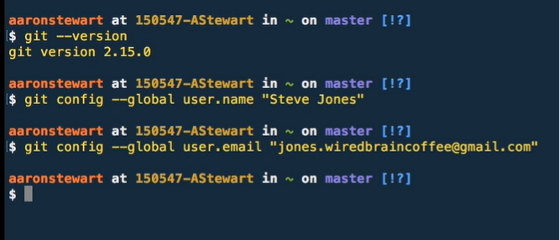

After you have finished installing Git, you can verify if the installation was successful by typing git ‑‑version. The response of this command will be the numbered Git version that was just downloaded. Now that we have verified that Git has been installed, the first thing that we should do is set our username and email address. When we use Git to make changes to our project's files, Git uses this information to identify who made these changes. Git has a tool called git config that allows you to set configurations to Git. So, to set a username, type **git config ‑‑global user.name**, and then the name in parentheses. Let's use Steve's name. And then to set an email address type **git config ‑‑global user.email**, and then the email in parentheses. Again, let's use Steve's information. Now that we have Steve's username and email address configured in Git, his file changes will now be identified to him. And since we're using the ‑‑global option, we'll only need to do this once and Git will apply it to everything we do in the system. If you want to change this global setting with a different username or email address, but only for a specific project, you can run the same commands, but without the ‑‑global option when you're in the project. This will overwrite your global settings, but just within that project, and keep the global settings for everything else. If you want to check your configuration settings, you can type get config ‑‑list, and it will list all of the settings Git has at that point. If you want to check a specific setting like the username, for example, you can type git config, user.name or any of the other settings that you have configured, and it will respond back with the set value just for that setting.

**Git Help**

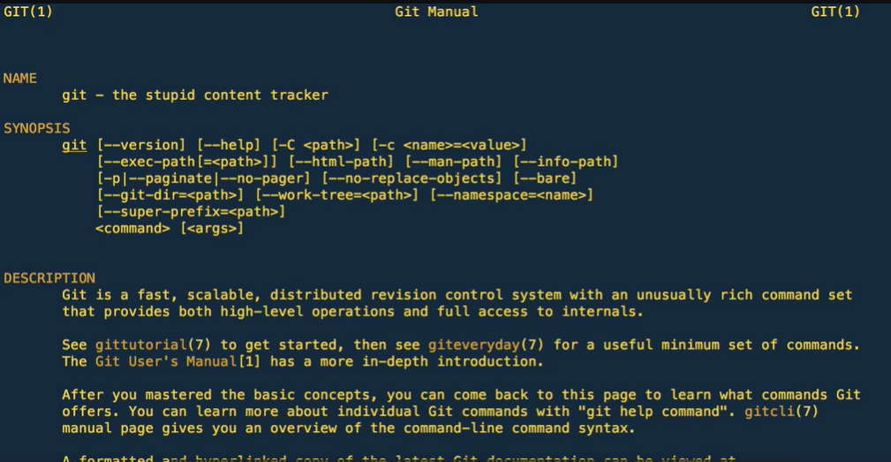

Now, if you ever need help with Git or if you forgot what git command does what, you actually already have the complete Git manual at your fingertips because you downloaded it when you installed Git. In fact, you have two help options. First, you have the full manual, which can be seen by typing **man git**, and covers pretty much every git command that you can make with a description of what it does. As you can see, it's quite long, and scrolling down to the bottom can take a minute. You'll also notice that the full manual has a section for high‑level commands, or what Git calls porcelain commands. These are your main git commands that are most commonly used day to day, and are the commands you'll use for maintaining your Git project, and the commands that we're covering in this course. If we scroll a bit further down, you'll notice the lower‑level plumbing section. Now these are commands that give you access to the deeper inner workings of Git.

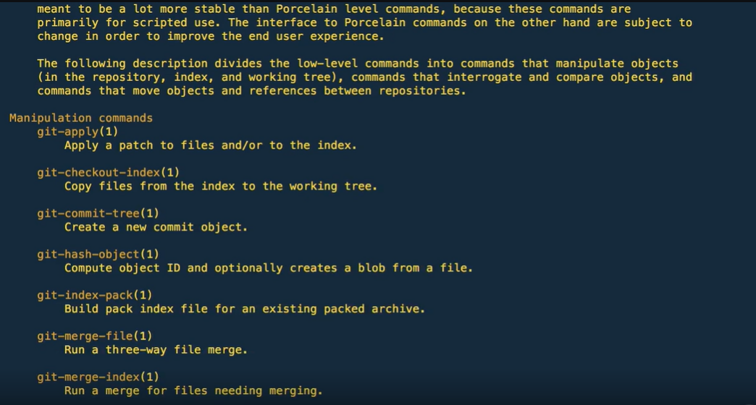

Many of these commands aren't meant to be used manually on the command line, but are meant to be used in tools or scripts. You can shortcut to a specific section in this manual by typing git‑help, and then the section you want. So, for example, if I wanted to read more about the config section, type git‑help config, and it takes you straight to that section in the Git manual. The second help option is a quick reference guide that has some of the most common and useful commands used in various situations. You can see this list by typing **git help**, and then it will return a much smaller list with commands that you'll use most of the time. This is a shorter list of the porcelain commands that is easier to get to than finding them in the full manual. At this point, don't pay too much attention to a lot of the commands in the full manual, especially most, if not all, of the plumbing commands. Most of them are for advanced Git usage, and using them without understanding exactly what they do can really mess things up. For now, just know that you have these helper guides whenever you need a quick reference.

**Initialize a New Git Repository**

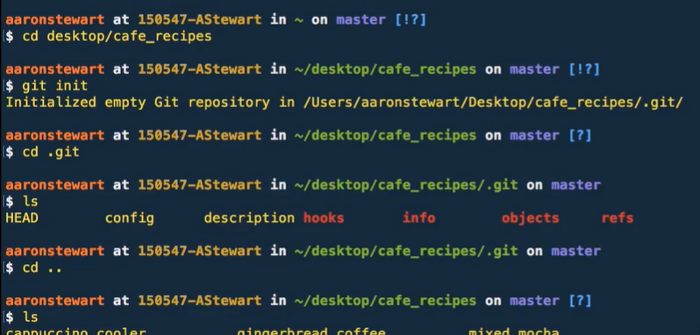

Now that Git is installed, it's time for Steve to add Git to his recipe project. This is done by initializing a new Git repository. A Git repository, which is often abbreviated as just repo, is a virtual storage of your project. In other words, each project in Git is referenced as a repository. To initialize a new project or a project that already exists, as is the case for Steve, you first need to cd to that project folder using the command line. Now Steve has his project folder saved on his desktop, so let's cd to his project by typing cd desktop/, and then the name of the folder, which in Steve's case is called cafe_recipes. Now that we're in his folder, initializing a Git repository is done by typing **the git init** command. Once executed, you'll then see a response message that says initialized Git repository in the specific file path of our project. By initializing your project, it added the Git configuration to a .git subdirectory that has marked this project folder and all of its contents to be version controlled. This .git subdirectory is hidden by default, but you can go into that folder by typing **cd .git**, and then you can use the ls command to provide a list of the files in this folder. You'll notice that there are several files that were just created, but for the scope of this course, just know that this .git directory just contains all of the important get metadata for this new repository. Now, as you learn more about Git, you'll understand more about what these files do, but for now, just know that they exist. We can get out of the .git subdirectory and go back up a level to our parent directory by typing cd dot dot. If we now type ls again, we get a list of all of the recipe files that Steve has saved under his project folder. Even though we've initialized Git on this project, the contents in these files haven't changed, they've only been added to be version controlled by Git.

**Send Your Code to a Code Hosting Provider**

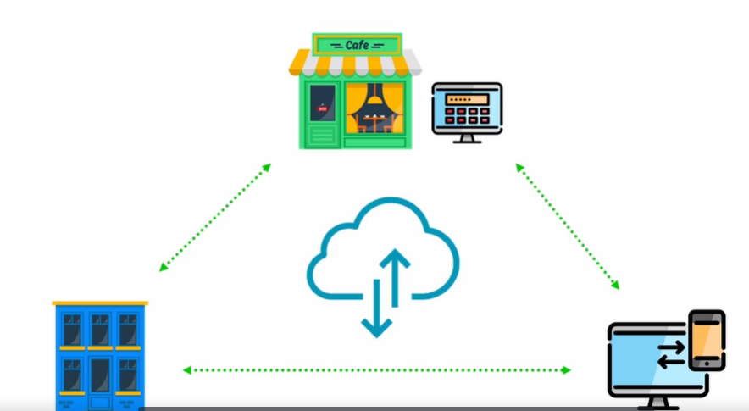

Steve has now installed, configured, and added Git to his project by initializing his project as a Git repository. His files are now being version controlled by Git, and they are ready to be tracked of any changes he now wants to make. But this only solves one of Steve's main problems. He now has a better way to manage his project, but everything is still local on his cafe computer. If he forgets his computer at work and wants to contribute to his project from his house or if he wants to access his project on one of his several other devices, he still can't work on his project because it's still only on his local computer at the coffee shop. In order for Steve to solve this problem, he needs a way to host his Git repository in an online cloud‑like setting. That way, he can sign into his Git repository online and pull down his project on his multiple devices. There are several companies that specialize in this type of product offering. Some of the most popular ones are GitHub, GitLab, and Bitbucket. These are web‑based Git repositories hosting services, which is exactly what Steve is looking for. With using one of these code hosting providers, Steve can push his local Git repository to their online hosting service where he can then access his repository any time that he has internet access. 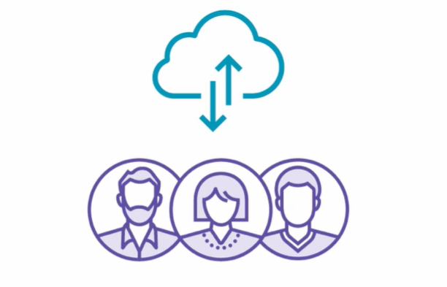 In addition to being a Git repository hosting service, the code hosting providers offer additional features to help improve your Git repository, add collaboration, and make contributions easier across other developers worldwide. The most important feature that these providers offer is its ability to integrate collaboration seamlessly into your Git repository. Now, being able to discuss and collaborate changes made to your repository with other developers, contributors, and team members is what makes these code hosting providers great at what they do. With so many great features they have to offer, there is a lot of information and details around them that won't be covered in this course. Now, regarding our Wired Brain Coffee project with Steve, he currently is the sole contributor to his project, so a lot of these collaboration features won't be discussed in full detail in this course; however, as Steve's cafe and project continue to progress and see success, he's working towards adding additional contributors to his project in the near future and is excited to leverage the collaboration‑rich features that these code hosting providers have to offer and take his project to that next level. But before Steve can start pushing his repository to a co‑hosting service, he first needs to choose a provider and then create an account. So since we need to choose one to move forward, let's go with GitHub and create an account to move forward.

**Create an Account with a Code Hosting Provider**

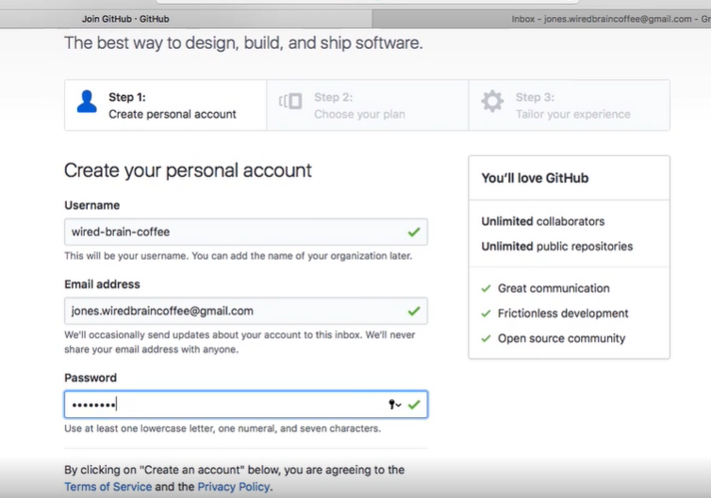

Creating a GitHub account is pretty easy and can be done in just a few simple steps. So, let's go to github.com where Steve can get signed up. At the home page, you'll see at the top‑right corner the option to sign in or sign up. Let's click the Sign up option to get started. We're then brought to a quick form to fill out by entering a Username, Email address, and Password. Let's enter in Steve's information. We'll need to pick a username that is available. Let's try wired‑brain‑coffee. And with that username available, we'll enter Steve's email address, and then we'll enter in Steve's password. Make sure to go over the terms of service and the privacy policy. We won't take time to read and discuss those in this course, but it's a good idea to understand what those are and to agree to GitHub's policy before continuing on. The next step is to choose the type of personal plan you want to have. Now there are two options. The first is a free plan to create unlimited public repositories that will be hosted on GitHub. The second is a paid plan to create unlimited private repositories. Now, since Steve will be pushing his sensitive cafe recipes to GitHub, it would make sense for him to sign up with the paid plan so that his repositories will remain private. The steps to push content to GitHub won't change with these two plans, other than the fact that only authorized collaborators that Steve can manage will be able to see his project. For now, let's go ahead and stick to the free public plan. Note that you can always cancel or upgrade your plan at any time. There are also a few other optional check marks that you can read more about if interested. One is for setting up an organization, which is best suited for businesses who need to manage permissions for many employees, and the other is to sign up for GitHub news, offers, and events. Again, for our purpose, let's just leave those two blank and then hit Continue. The last step is optional, but it contains a few questions to answer so that GitHub understands its users better. They're basic questions, but again, for our purpose, let's go ahead and skip this step by clicking the option at the bottom of the screen. We then see a page that says Learn Git and GitHub without any code! GitHub, then provides two options, one to read a guide and the other to start a project. Since we'll be going through these steps with Steve's project, let's get started by clicking on Start a project. This then takes us to one last screen where it asks us to verify our email address that we entered at the beginning. So, let's jump over to Steve's email so GitHub can verify our account. In the email, we'll click on the Verify email address, which will verify that our email address with our GitHub account and will take us back to GitHub where we see the Start a project button again. Let's click that button to push our local Git repository to GitHub.

**Push a Git Repository to a Code Hosting Provider**

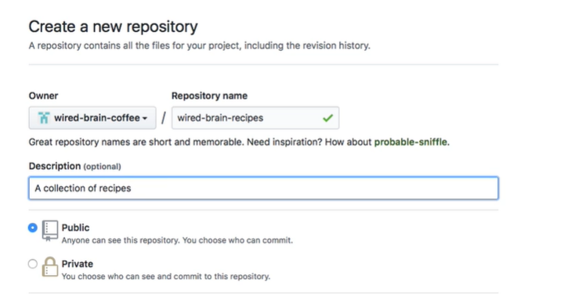

Creating a new repository on GitHub starts with giving it a name. Steve has chosen wired‑brain‑recipes. Next, we can add an optional description. You then have the option to make this repository as public or private, and then there is an option to initialize this repository with a README file. A **README** is a quick and simple way for collaborators to learn more about your repository. We can add a README file by clicking the button here or by adding it using the command line. It's as easy as clicking this checkbox on GitHub to add one to our new repository, but we'll add it to our local project using the command line before pushing it to GitHub. There are two other options, one is to add a **gitignore**, which is a way to add files that you don't want version controlled by Git, and it's something we'll discuss a little later on in this course. The other is to **add a license** to your repository. You can learn more about the different licenses you can add by clicking the Information icon next to the drop‑down option. For real projects, these options are probably a good idea to add, as recommended by GitHub. But for our example project with Steve, we'll leave both of these options as their None default and continue with clicking the Create repository button. We're now taken to a GitHub page that provides some different scenarios and steps on how to push our repository to GitHub. We're first prompted to either use HTTPS URLs or SSH URLs. The HTTPS URLs are recommended and are the default option. Now, these URLs will work really everywhere, even if you are behind a firewall or a proxy. Using HTTPS URLs to push or pull changes to or from your repository, GitHub will ask you for your GitHub username and email address for verification. There is also an option to use the SSH URLs to provide access to your Git repository via the SSH Secure protocol. In order to use these SSH URLs, you need to first generate an SSH key pair and then add that public key to your GitHub account in your profile settings. Using SSH URLs to push or pull changes to or from your repository, GitHub will prompt you with a password, and you'll need to enter in your SSH key passphrase. Now, we're not going to go over setting up SSH, but you can find more information at the URL listed below. So for Steve's project, we're just going to use the default HTTPS URLs. Since we already have a Git repository, we're going to use the second option to push an already existing repository from the command line to GitHub, but we'll use some of the steps in the first scenario to create a README file and add our first commit before adding the remote origin and pushing our repository to GitHub. Before we switch over to the command line, we'll need to copy the HTTPS URL at the top of the page. Jumping over to terminal, and once there, let's add of README.md file by typing **echo**, and then in **parentheses, #, or the pound symbol, space, wired‑brain‑recipes, and then two greater than sign symbols with the word README.md. The echo command says that we want to write** **wired‑brain‑recipes** with an H1 HTML header into a new file called README.md. Now, you can really put anything you want into this README file, but by default, GitHub Just includes the name of your repository. Now that we've added the README file to our project, it's currently being listed as an untracked file, similar to the rest of our recipe files. Now, we've initialized this project to be tracked by Git, but we need to add these files to our staging area so that they can be committed and thereby tracked by Git. We can add these files by typing the git command git add and then dot. This command will add all of these files to our staging area. And now that these files have been added, we can now make a commit with a message that says first commit. We can do this by typing git commit ‑m for message, and then in parentheses, first commit. Git then responds back with some interesting information, and it can tell us on what we just did. We then need to connect our local repository to the one we just created on GitHub by linking the two repositories with a git command. This can be done with the **remote add origin and then the HTTPS URL that we just copied**. This command adds the origin GitHub repository to our local repository by creating a link that allows us to push and pull changes between the two. Now, we need to push our repository that is now pointing to our GitHub repository by typing **git push ‑u origin master**. We're then prompted to enter in our GitHub username and password, and if verified, Git responds back with some information that at the bottom says, Branch 'master' set up to track remote branch 'master' from origin. Now, this means that everything worked, and we have successfully set up to track our local Git repository from the origin GitHub repository. Now, if we go back to our GitHub profile's main page, we now see that we have one repository listed. And if we click on that Repositories section, and then on the actual repository, we can see that our wired‑brain‑recipes Git repository that was local is now being hosted and tracked on GitHub.

**Summary**

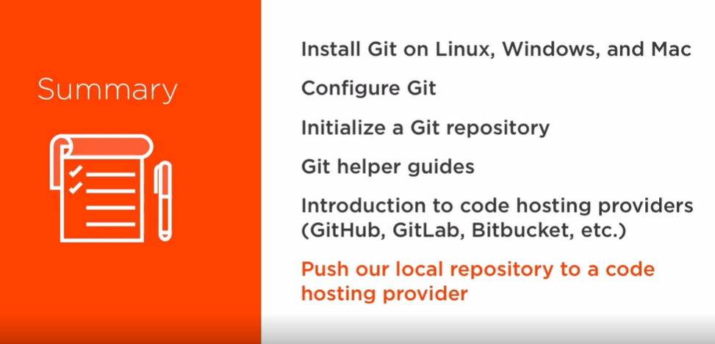

In summary, we learned how to install Git on Linux, Windows, and Mac systems, as well as how to configure Git by adding our username and email address as global settings to Git, and even how to set individual settings to specific projects. We then learned how to initialize a Git repository by using the **git init** command to our existing recipe project. This command added a .git subdirectory to our project that contains the necessary metadata for Git that works behind the scenes. We then learned about the two **Git helper** guides, with one being a full **Git manual** that details the Git porcelain commands, which consist of the basic, most common Git commands, and the more advanced plumbing commands, which are used as building blocks for creating scripts and tools. We were then introduced to some code hosting providers and learned that they are web‑based Git repository hosting services that we can use to push a project's repository for collaboration among contributors. By doing so, we can then access our project from any computer or supported device that we have internet access. When we pushed our repository to GitHub, we used the git add and git push commands to accomplish certain tasks. Git then responded back with information on what just happened. In the next module, we're going to dive more into Git commands such as these and learn more about what they do and what the information actually means that Git responds back with. These next Git commands are referred to as the common porcelain Git commands that we referenced earlier. This next module is pretty important, so sit back, adjust your seat, and get ready to master Git.

**Basic Commands of Everyday Git**

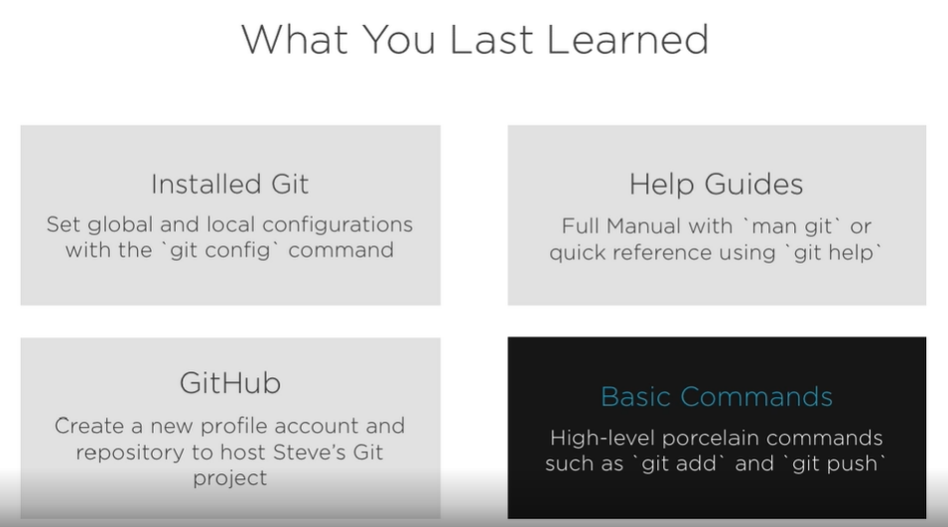

Introduction

Hi, welcome to Getting Started with Git. This module is all about understanding some of the basic commands of everyday Git. In the previous module, we installed Git and learned how to set some global and local configurations using the git config command. We also learned how to locate and use two main help resources, one being a full Git manual by using the man git command and the other being a quick reference guide by using git help. We were then introduced to GitHub, the web‑based Git repository hosting service, where we learned how to create a new account and create a new repository to push our existing local Git repository to GitHub. As we continued our story with Steve and his Wired Brain Coffee project, we then pushed his repository to GitHub using the command line. By doing so, we used some basic high‑level commands referred to as porcelain commands, such as git add and git push. We then saw some interesting information that Git provided as a response when we executed these commands. Now, in this module, we're going to understand this information that Git provides in these responses and learn more about what these git commands do and how we can use them to manage our project. The commands introduced in this module are common everyday git commands that you'll be using quite frequently when working on a git repository. So let's get started by going back to our terminal command line where we left off.

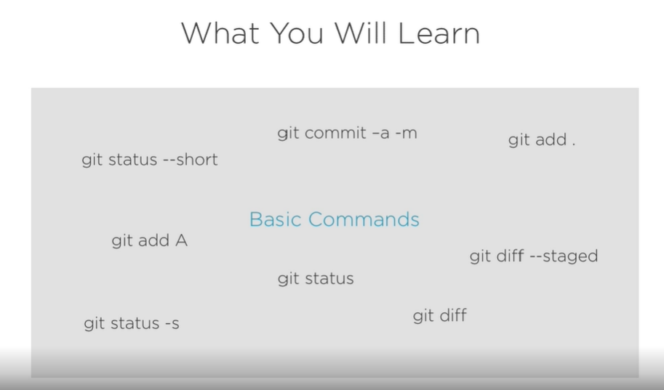

**Git Status**

As you have probably noticed, a nice thing about terminal is that we can see the history of commands that we've already executed. They don't go away when we run another Git command. Now, this is great for remembering the steps taken to reach our current state. But as you can see, the majority of our screen is taken up with our previous Git commands. This can leave things a bit cluttered, especially when using help guides or similar commands that respond back with a lot of information. It's often nice to clear this information out and start with a clear terminal window. We can do this by typing the clear command. This clears out our window and moves our command prompt to the top of the screen. Now, we didn't erase this command history. We can always scroll back up to view our previous commands. All the clear command does is move this history out of view. Now, before we ran clear, the last command we ran was to push our committed changes to the origin master by typing git push ‑u origin master. Remember, the origin is the repository version that sits in our GitHub profile. Since we just pushed our local repository to GitHub these two repositories, our local repository and the remote origin repository on GitHub, should be the same. But with Git, you don't have to guess or try to keep track of the current state of your project or files. You can check the status of your project at any time by using the git status command. If we type git status in our command line, Git will respond back with a few lines of information. The first line is stating the branch that we're on, which is the master branch. Now, back in a previous module, when we initialized Steve's Git repository, Git created a master branch automatically.

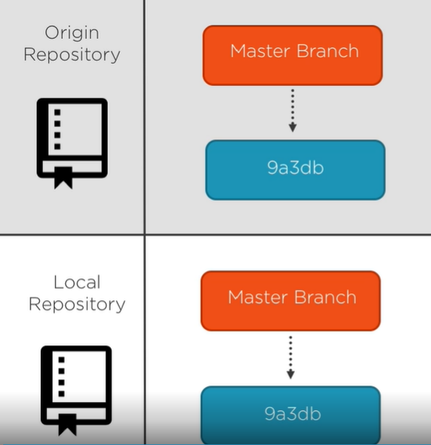

A branch in Git is a lightweight, movable pointer to your project at a specific point in time. Now, since our two repositories are in sync with each other, our local master branch is equal to the origin master branch. This default branch that was created is called the master branch. If you're a little confused on the idea of a branch, don't worry. We're going to cover branching in detail in the next module. But for now, just understand that when you initialized your Git repository, Git created a branch called master. When you make changes in Git, you make them on a specific branch.

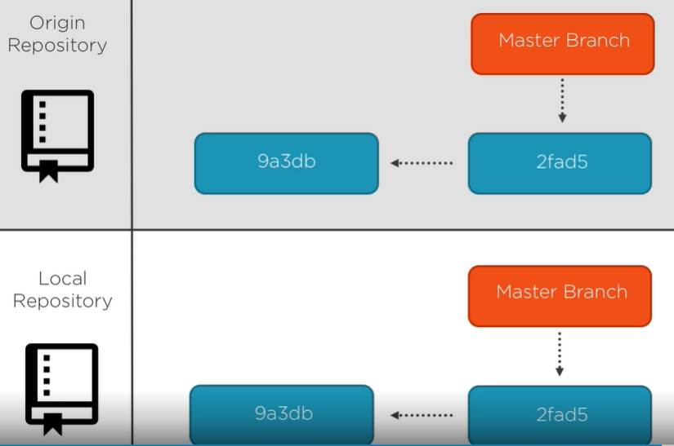

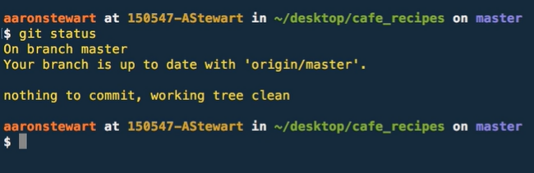

Now branching is a core concept in Git and a feature that adds a lot of value by allowing many different types of workflows that can involve many different types of branches. But at least for right now we'll keep things simple and make all of our changes directly on the master branch. The second line in the response mentions that our branch is up to date with the origin master. Now this one is pretty easy to understand. It's saying our local branch, again, which is master, is up to date with the origin master branch, the one being hosted on GitHub. And the third and final line is saying that there is nothing to commit and that our working tree is clean. If you remember from the last module, we haven't modified any files, so there are no changes yet in our working directory and nothing yet that has been staged that is still waiting to be committed. The git status command is a simple but important command because it shows us the state of our project at this particular point in time. Now, this is a Git command that we'll be using quite frequently moving forward.

**File Stages**

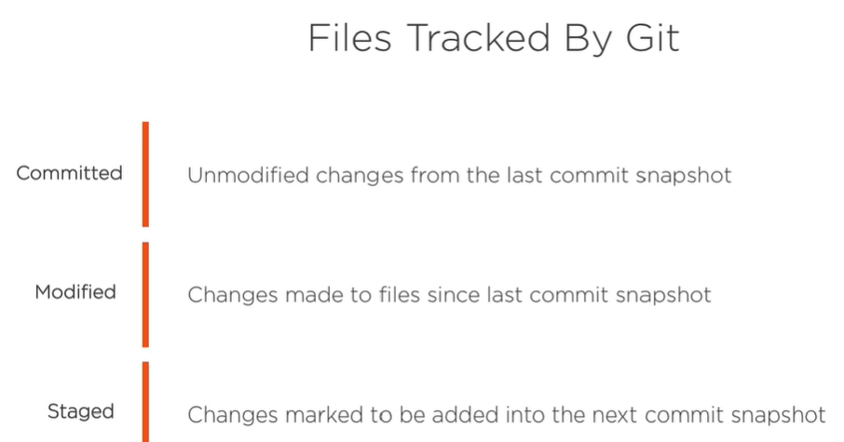

Now that our local repository is equal to our origin repository, Steve is ready to make some new changes in these files. Each file in our project can be in one of two states. It can be tracked or untracked by Git. Remember, tracked files are ones that were in the previous Git snapshot.

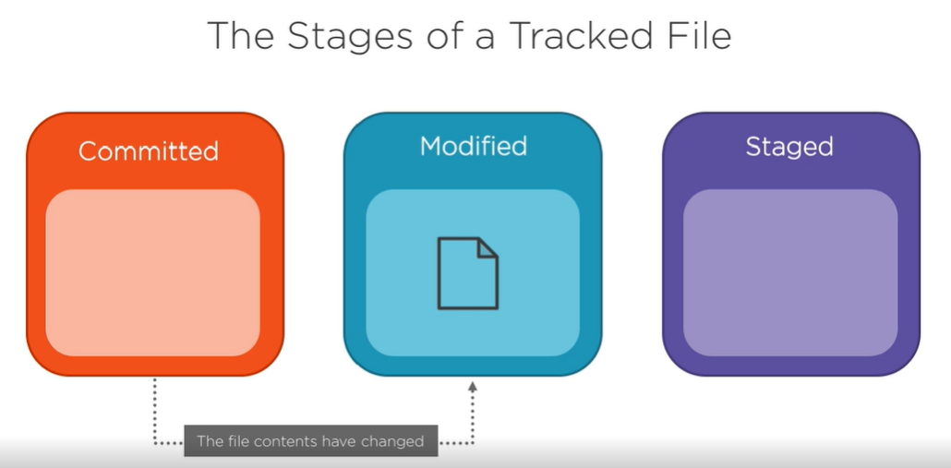

Tracked files can be in one of three states: committed, which are unmodified changes from the last snapshot; modified, which are files that we've added changes to; and then staged, which are files that we've marked to be added to our next commit snapshot.

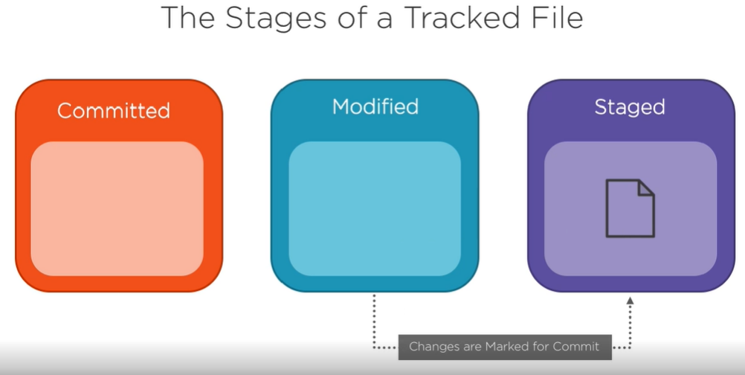

When we make a change to our committed or unmodified file, it moves from a committed stage and into the modified stage. When we're satisfied with our changes and we want to stage them for commit, we add them to our staging area.

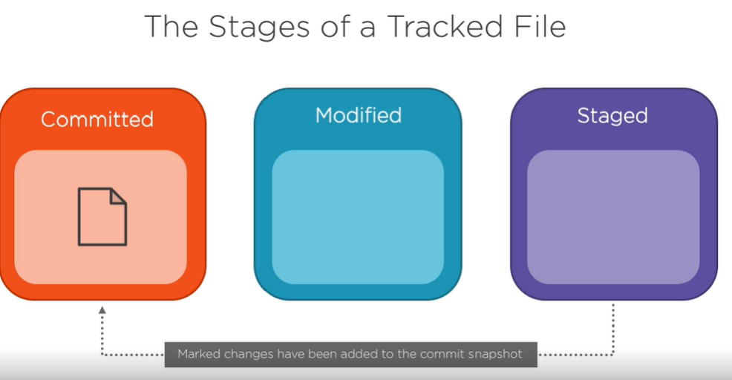

We then take the changes in the staged area and commit them to our repository. These changes are now saved in our repository in that commit snapshot and they are then moved back to the committed stage. Now going back to the terminal command line, we can run git status and see which files are in which state. Now since we have nothing yet to commit and our working tree again is clean, and all files are in the committed state from the last snapshot, as we make changes to Steve's project, keep in mind the three stages and see if you can predict the state a file will move into as we run these commands.

**Track a New File**

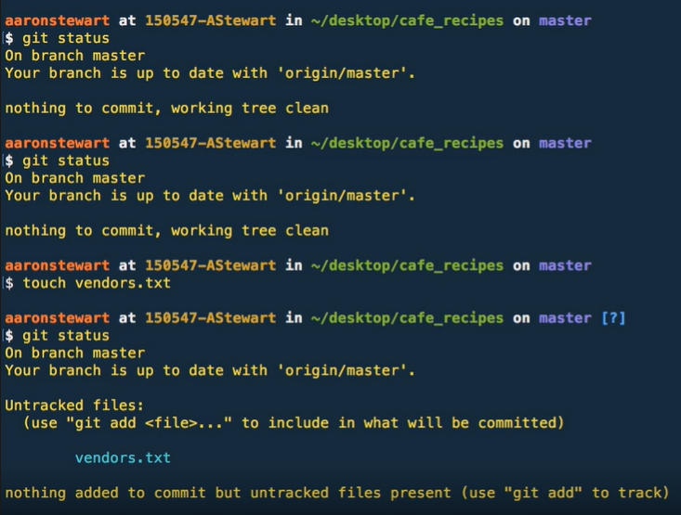**d**

In Steve's repository, he realizes that he doesn't yet have a file to keep track of his suppliers. So, Steve wants to add a new file into his repository called vendors. So, let's add this new file to Steve's repository by typing touch vendors.txt. If we run the git status command, we now see that the vendors.txt file is now showing under the untracked files. Remember, untracked means that Git sees a new file that didn't exist in our last commit snapshot. Now, Git won't track anything unless we explicitly tell it to do so, but Git does provide us with some helpful information on how to add this untracked file. The bottom message says nothing added to commit but untracked files present. Git, then lets us know how to add an untracked file by using git add and then the name of the untracked file. So, let's start tracking this file by typing git add vendors.txt. If we now run git status, we now see that the vendors.txt file is showing as a new file being tracked and that it's a new change waiting to be committed. Modified files that have been added are now in our staged state. Git has provided us with another message that says use "**git reset HEAD**" and then file to unstage. Resetting or removing files from the staged area is something we're going to cover in the next module. For now, we just want to commit this new file. We can tell that this file is staged because it's now under the Changes to be committed section.

**Stage Modified Files**

If we committed this new vendors.txt file now, the contents of this file, when we perform the git add command, will be committed to our project in that snapshot. But before committing this file, let's add some changes to a file that was already being tracked. If we type the ls command, we see a list of all files under our project directory. We see the vendors.txt file, because we've added it to our local master branch, but we haven't committed it yet. Let's open up employees.txt, a file that is already being tracked, and add a new employee that was just hired. We can do this by using the command **open ‑a, and then the name of your text editor, which, in Steve's case, is atom, and then the name of the file**, employees.txt. Now, let's add the new employee and his information to the file. Let's now save that file and go back to our terminal window. If we type git status again, we see that the employees.txt file is now under the changes not staged for commit section. This means that the file is being tracked by Git and has been modified in our working directory, but it hasn't yet been added to our staging area for commit. Now we can stage this file by using the git add command. The git add is used to track new files, as well as add modified files to be staged. You can think of the git add command as add this file to be in the next commit snapshot. So let's type **git add employees.txt** and add it to the staging area. Let's now run git status again and see what happened. Both files are now staged and are showing as changes to be committed. Git provides us with information on what kind of file is being staged next to the file name. We can see that the employees.txt file is a modified file, and the vendors.txt file is a new file ready to be committed. But before we commit these files, Steve realized that he recorded the new employee's phone number incorrectly. So let's reopen the employees.txt file and make that change. We can open the file again by typing open ‑a atom employees.txt, and let's make the change. After making the change, let's save our file again and go back to our terminal window. Let's run git status again to see what happened. Noticed that employees.txt is now showing as staged and ready to be committed, as well as showing as modified changes not yet staged. Now this may seem a little confusing. I mean, how can a file be in two states at the same time? Well, the answer is how and when Git stages a file. When we first staged our employees.txt file by using the git add command, those changes were added at that point in time to be staged. When we fixed the phone number and then resaved the file, Git sees this as a new change that was not added when we previously staged that file. If we committed the files in our staged area right now, the version of employees.txt when we added it to the staging area, is what will be committed into the snapshot. This will not include the fix we just made, since we haven't added that change to be included into our next commit snapshot by staging it with the git add command. If you change a file after you run git add and you want those changes to be included in your next commit snapshot, you have to run git add again on that file to add those changes to be staged. So let's run git add employees.txt again and then run git status to see what happened. We now see that the employees.txt file is now only showing in the staged area, which, again, are changes to be included in our next commit snapshot.

**Short Status**

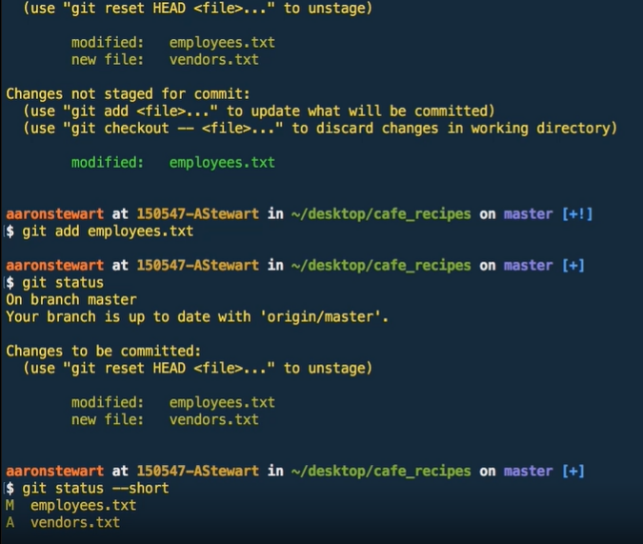

So far, we've run the git status commands several times already, and each time we run get status, Git provides us with a pretty comprehensive response. But after getting used to Git's response when using git status, it can be useful and nice to have a way to see these changes in a more compact response. Git has provided a short status that provides the same amount of information, but in a much smaller and concise way. Now we can see this shortened response by typing git status ‑s or git status ‑‑short. By running this command on our project, we get back a response that has our two files that are waiting to be committed but now with some interesting letters in front of them. Right now, I bet you're pretty confused by looking at this response because it doesn't make much sense unless you understand the format response that the short status uses. The key to understanding the short status response is knowing what the letters in front of the files mean and their placement. After running this command, Git will place the name of the files in the far‑right column. There is then a middle column and a far‑left column. The far‑left column indicates that the file has been staged, and the middle column indicates that the file has been modified but remains in the working directory.

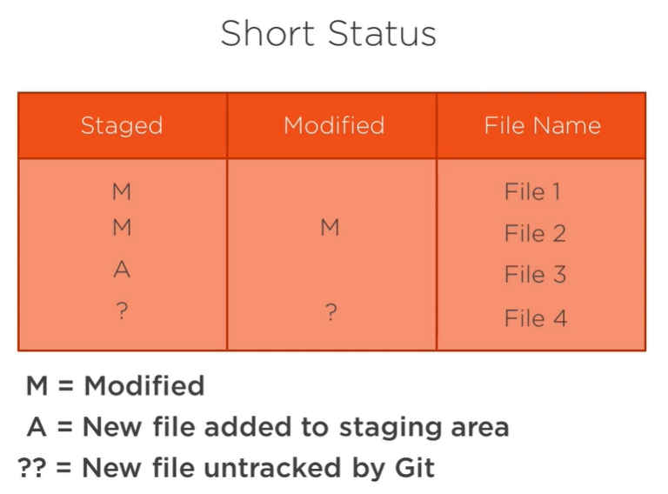

The letter **M means modified**, and the letter **A means new files** that have been added to the staging area, and two question marks mean that there is a new file that is untracked by Git. So in this example, File 1 is a modified file in the staging area, File 2 is a modified file in the staging area, as well as modified in the working directory. This was the same case with our employees.txt file when Steve made a change after staging it. And File 3 is a new file added to the staging area. And File 4 is a new file created but not yet being tracked. So jumping over to our terminal window again, we can see that our employees.txt file is showing modified in the staging area, and our vendors.txt file is a new file that has also been staged.

**Git Diff Explained**

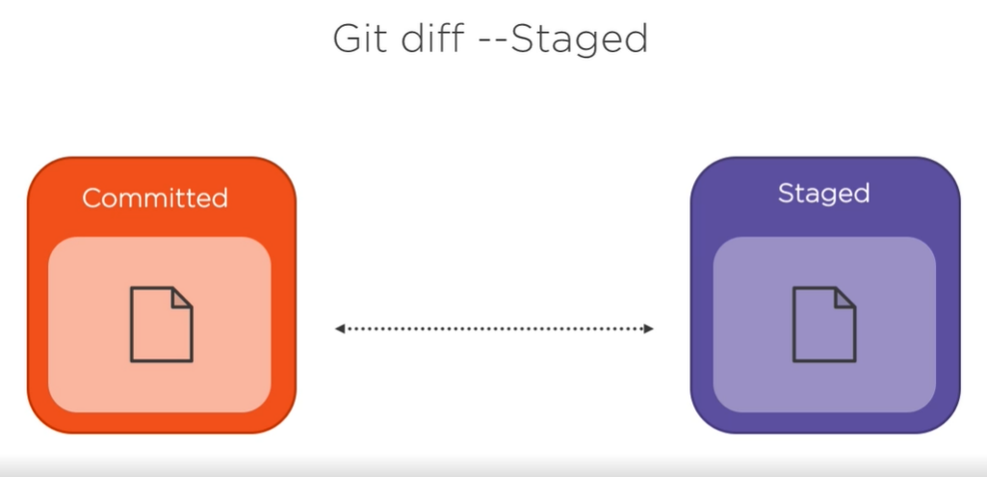

The short status is nice if you just want to see which files reside in which states. But what if you want to go the other direction and see more information than just what git status shows? Well, Git has a command for that, too. If the git status command is too vague and you want to see the actual changes being made in these files and not just know which files have been changed, you can use the git diff command. You can **use git diff to answer two questions,** **what changes have I staged that are ready to be committed, and what changes have I made but not staged?** If we want to see the changes we've staged that will go into our next commit, we can use **git diff ‑‑staged**. This command **compares our staged changes to our last commit snapshot**.

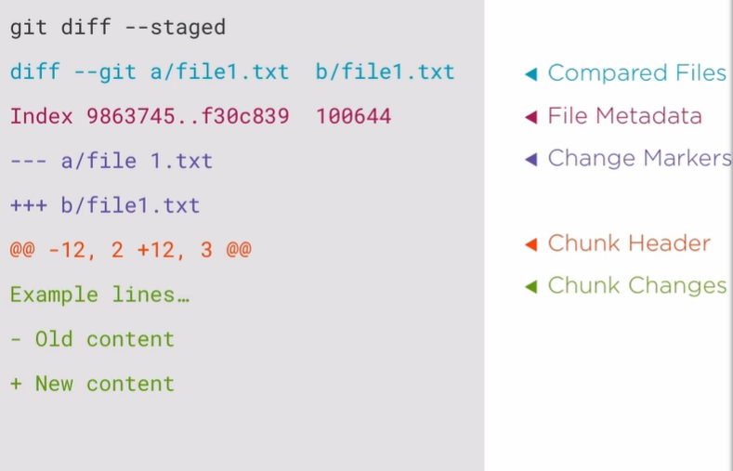

When we run git diff ‑‑staged, we're going to see an interesting detailed response. So let's go over how to read this output. The first thing we see are the compared file versions. Git diff is comparing file a with file b. Now in almost every case, file a and file b will be the same file but just in different snapshot versions. This is shown with diff ‑‑git and then file a, followed by file b. The next line is the file metadata. Now this is technical information of our files. The first two numbers are the hashes or IDs of the two file versions that are being compared. As we were briefly introduced to SHA‑1 hashes in a previous module, Git identifies a file object at a specific version by using these SHA‑1 hashes. The last number is most likely going to be 100644. Now, this is just a internal file mode identifier that represents a normal file. Now there are other number identifiers, but diving into this metadata information is more advanced Git knowledge that won't be covered in detail in this course. Again, for now, just know that it's there and the basics of what it is. Next, we see the change markers for file a and b. File version a is assigned with the minus symbol, and file version b is assigned with the plus symbol. Next, there is the diff chunk, which is made up of two parts, the chunk header and the chunk changes. At the top of this chunk is the chunk header, and the header is enclosed with two @ symbols on each side and will tell you which lines were changed in the file versions. File a is represented with a minus sign, and file b is represented with a plus sign. In this example, the ‑12 is saying that the minus sign, again, being file a, begins at line 12 and then has 2 lines that were modified. The +12 is saying that the plus sign, being file b, also begins at line 12 and then has 3 lines modified. After the chunk header, we have the chunk changes that contain the actual line changes. Now this often includes a few lines of unchanged lines before or after the changes to help provide context of where these changes are being made in the files. These changes will either have a minus or a plus sign in front of the change to show you what version that change is occurring in. However, for files with only one or two lines of content, these extra lines may not show up. So let's jump over to our terminal window again and run this command to see how it looks in our project.

**Git Diff in Action**

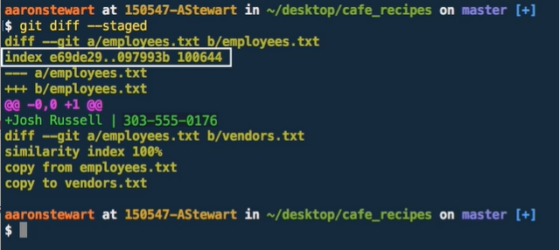

Let's clear out our window again by typing clear to bring our Command Prompt up to the top of the window. By running the **git diff ‑‑staged** command, we see that the compared a and b version files is employees.txt. Next, we have the metadata with these file version hashes and the file mode identifier, which is the id for a normal file. We then see the change markers for the two file versions of employees.txt, with the minus being the last committed snapshot version and the plus being the new changes that are in our stage state. We then see the chunk header that shows us the line changes being made in these files, and then we see the chunk changes where we actually see what is being changed. Now, we also see another compared a and b version files, but unlike the employees.txt file comparison, this file a and file b comparison is with different files. File a is employees.txt, and file b is vendors.txt. Below, we see some interesting information that says, similarity index 100%, copy from employees.txt, and copy to vendors.txt. So what's going on here? Well, the reason for this is how Git thinks about filed changes Now, Git doesn't care what the name of the files are. Git really only cares about the content inside of those files. Now, we added a new vendors.txt file that is currently an empty file, and the other file in our staging area is the employees.txt, which was also an empty file before we added some content to it by adding the new employees information. Now, Git sees this similarity and thinks that we just copied the employees.txt file and then renamed it to vendors.txt. The similarity index is the percentage of unchanged files. Well, and since these two file versions are the same, the similarity index is 100%, so Git thinks it's the same file. Now, since this is not the case, we can get around this by explicitly telling Git that this is not a renamed file, but it is in fact a different file.

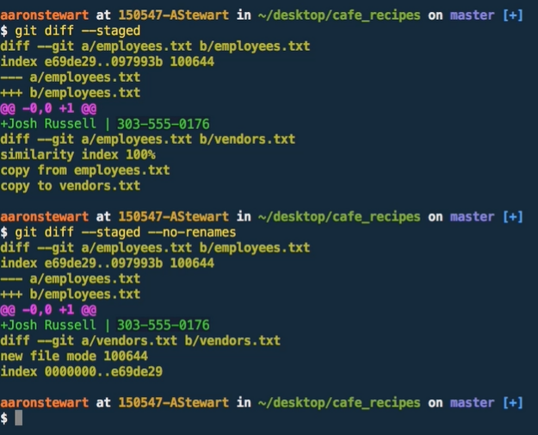

And to show us the Git log as it should be, we can see the correct dif information by again typing **git diff ‑‑staged**. But this time, let's add the ‑‑no‑renames option. We now see the compared a and b version files for vendors.txt and some similar formatted information that was in our employees.txt version differences. Git tells us that this is a new file with the normal file identifier, and then we see the file metadata. Notice that the first hash reference is a hash of 0s. Because this is a new file, Git wasn't previously tracking this file so there is no hash reference to compare it with. The second hash, which is e69de29, is the new hash for the contents inside vendors.txt. But just a second, the vendors.txt file is empty. There isn't any content in this file. Since Git is now tracking this file, Git needs to create a hash of contents from the file. Even if the file contents are empty, creating a hash on an empty file responds back with the hash reference of e69de29. Remember, Git only cares about the hash reference of a file to keep track of its content. Since the vendors.txt file has a hash of e69de29 and the beginning file version of employees.txt before the added employee change, being file a, also has the same hash reference of e69de29. This is why Git thought we just copied and renamed the file. Now, the git diff ‑‑staged shows us the information on changes that are staged. But what about changes that haven't been staged and are still in our working directory? We can see this information by just using **git diff**. By running that in our terminal window, we see that we get nothing in response. Well, this is because we currently don't have any changes in our working directory. So let's add some content into our vendors.txt file and see where these changes show up. We can open it using open ‑a atom vendors.txt. Let's now add a new vendor with a name, location, and phone number. Let's save this file and return back to our terminal window. If we run git diff, we now see this exact change in our vendors.txt file being compared to its previous version. If we run git status, we see that this file change is modified and in our working directory. So let's add this change to be staged with the other changes by typing git add vendors.txt. We can verify our actions by typing git status again. And now, we see that both our employees.txt and vendors.txt files have staged changes ready to be committed.

**Commit Changes**

At this point, let's add another vendor to our vendors.txt file by opening it back up in Atom using open ‑a atom vendors.txt. Underneath Jones Coffee Cups, let's add another vendor called West Summit Supplies with their location and phone number. Now, let's save this file and go back to our terminal window and run git status. As expected, we now see our vendors.txt file as modified and in our working directory. At this point, we can add it to our staging area by using the git add command and then run the git commit command to commit this change to our repository. Now, going through these series of steps for multiple changes is nice for organization, but it can be a bit unnecessary for small, simple changes, such as this one. Now, Git provides a shortcut if you want to skip the staging area completely and jump right to committing your changes. You can use this shortcut by typing git commit and then the ‑a option.

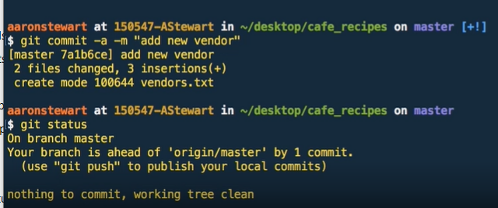

The **‑a option automatically stages all changes in your working directory that are being tracked by Git, essentially skipping the git add step.** In the same command, you can then use the ‑m option to add a commit message, as we did before. So let's type **git commit ‑a ‑m and then our message**. If we then run this command, we can see it in the Git output that our commit snapshot was successful. Let's now run git status to double check. As you can see, there is nothing to commit, and now our working tree is clean again. We just made our first commit. Git also responded with some output to verify that everything was committed successfully. Git provides the branch we made the commit on, which in our situation, is the master branch. We then see the SHA‑1 hash from the commit, as well as the commit message that we provided. We then see the number of files that we changed and some stats on how many insertions and/or deletions that were made in these files for this commit. If a new file was added with this commit, Git shows us that too on the next line that says create mode 100644, which is saying a normal file was created, and then the name of the new file, vendors.txt.

**Summary**

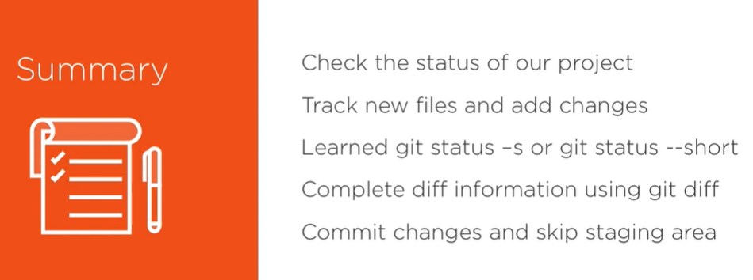

In summary, we've learned how to check the status of our project using the git status command. This is a command that we use often to frequently check how changes can move from our working directory to our staging area. We then briefly revisited the different file states that we learned in depth from a previous module and then used the git status command to actually see how our files move around in Git. We then learned how to track a new file by using the git add command, as well as using the same command to add our modified changes to the staging area. Then, we learned about a condensed version of the git status command by using git status ‑s or git status ‑‑short and then learned how to read the output of that command. In contrast, we then learned how to get more status information by using the git diff command and then learned how to read that output that consisted of some Git metadata, chunk headers, and the chunk changes for each modified or a staged file. We then learned how to commit our staged changes by using the git commit command. Committing our changes, we then learned how to skip the staging area by using the ‑a option in our commit command that resulted in taking any modified changes that were being tracked and then adding and committing them in the same Git command. Now we still have some very important topics to discuss. In fact, we've only yet introduced one of the most important things about Git. So, in the next module, we'll cover a few more basic Git commands to help us manage our project better. And then, we'll dive into one of Git's core features and see how we can elevate our Git project to the next level.

**Extended Commands of Everyday Git**

These are very important commands. Now, we have a lot to cover in this module, including a core concept.

**Push to Remote Origin**

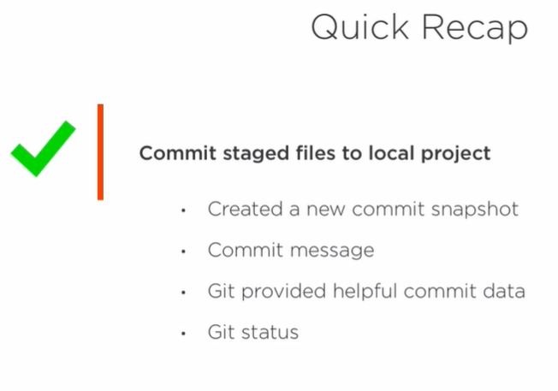

The last command we ran, other than the git status command, was to commit our staged files to our local project. By committing these files, we created a new commit snapshot that now includes our changes and moves our local master branch pointer to our newest commit.

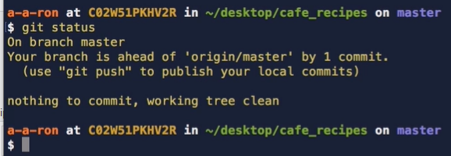

We did this by adding a commit message, and then Git returned some information to confirm a successful commit. Git then provides some information on the files changed with the number of insertions and deletions made to each file. We then ran the git status command to see the status of our local project, and this time, Git returned some new information we haven't yet seen with the git status command. So, let's jump back over to our terminal window to where we last left off. Let's run git status again to see the current state of our project. Git now tells us that our branch is ahead of 'origin/master', which again is our project being hosted on GitHub, by 1 commit. Git, then provides a helpful note on what is a common next step after commit is made. Git says, use git push to publish your local commits. Now remember, when we made this commit to our local project, those changes were only on our local project. If we were to view our project version on GitHub right now, it wouldn't have any knowledge of this commit.

Notice that we don't have to push our commit to our project at 'origin/master' every time we make a commit. Now we can continue to make commits to our local project as much as we want.

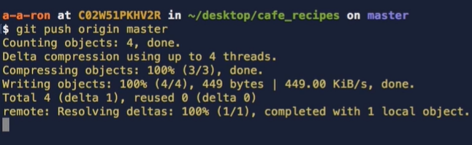

And then when our local project is at a point where we want to send our changes to our origin project, we need to push our local project upstream. We can send our changes to our origin project by using the **git push** command and then our **remote name, which is origin, and then the branch name** we want to push up to, which in this case, is master.

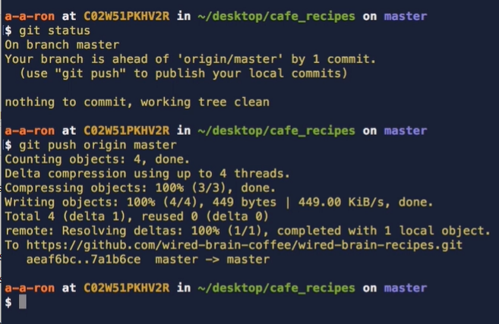

So let's go ahead and run this command now to push our local changes to our origin project on GitHub. It verified. Git now returned some confirmation data to let us know the push was successful. We see some compression information, as well as the GitHub URL path to our project repository that we were pushing to, along with the SHA‑1 hashes and the local master to origin master mapping. Now, there's a lot of specific information here to digest. But the important thing to note is that our push was 100% successful, as shown in the Git response and that our one commit was pushed to the origin repository without error.

**Check Commit History**

Let's run clear to bring our command prompt back up to the top. Now that we've pushed our local changes upstream to our origin repository on GitHub, let's run the git status command to see the state of our local project. We now see that our branch is up to date with 'origin/master' and that there is nothing to commit and currently nothing in our working directory or working tree. Now at this point we've only made two commits so far on our local project, the first being our initial commit when, at the beginning of our project, we ran git init, created a README file, and then made a commit with the message of first commit, as we then added the remote origin project URL that was provided by GitHub when we created our repository placeholder to host our project and then pushed our local project to GitHub. The second commit, being the one we just made with the commit message of add new vendor. Now, as you can probably guess, we don't have to keep track of each commit we make. As our project progresses and more and more commits are made, it will become unrealistic to mentally keep track of all commits and changes that have taken place. So, Git has a way to view our existing commit history by using the git log command.

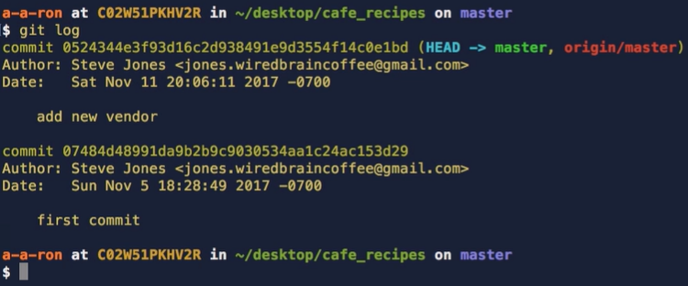

By running **git log**, Git returns some information related to our previous commits. And, by default, the git log command lists the commits made to our project in reverse chronological order, being the most recent commits will show up first. Up to this point, we've only seen part of the SHA‑1 checksums that we've made commits or compared file versions using git diff. But with using git log, we see the full SHA‑1 hash of our commits. We also see the name and email of the author who made these commits, which in our case, is Steve. The author and email configurations were set up using the git config command earlier in this course. We also see the date with the timestamp of when the commit was made, as well as the commit message for each commit. And as you can see, this is a quick way to have a high‑level overview of our previous commits and know who made each commit, when a commit was created, and what that commit was changing. Currently, viewing our commit history like this works well for us now, but as Steve's project progresses and more and more commits are made, looking for a particular commit by just using git log, we'll end up with a lot of scrolling to find the commit that we're looking for. Also, git log just shows us some basic information on each commit. It would be nice to dig into a specific commit to see what exactly was changed in that commit, similar to the results that we saw from using git diff. Well, as it turns out, there are a lot of options that can be used as parameters when using **the git log** command to give us exactly what we're looking for. Navigating our project's commit history is pretty important, but with so many options, it can be a bit confusing on knowing how to get the data we want or even where to get started. So, to begin, let's go over some of the most commonly used options when using git log. But remember, there are many, many more options to use with git log in getting the exact data the way you want it and the different ways to modify the commands we're about to learn. But this will give us a good starting point to move forward. If we want to limit the number of commits shown in the log, we can type git log and then the number we want to limit the log to. Now, since there are only two commits so far in our **log**, let's type **‑1** to limit the git log output to one commit, and then hit Enter. We see that only the add new vendor commit was returned in the log. Remember, the log output returns the commits in reverse chronological order, so we get the latest commit first. Notice that nothing has changed in the log output response with this command. We simply just asked for a limited number of commits to show, which was one commit. But what if we want to see all the commits, but in a more simplified way?

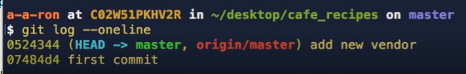

Well, we can use the **git log ‑‑oneline** command. Now if we type that into our command line and hit Enter, we get a list of all our commits in a single line format. Each line in the response is a commit, and it has the commit message, as well as a few digits of the SHA‑1 hash of that commit. This is a great way to see a simplified, high‑level overview of all the commits in our project history.

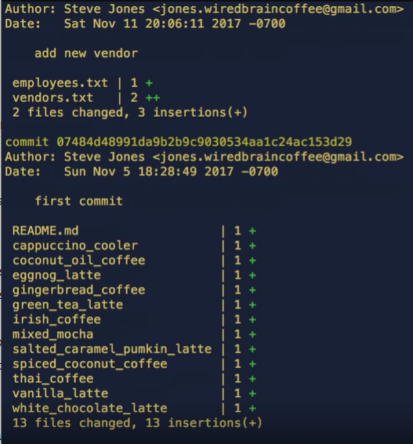

Now, let's go the other direction and get a detailed view of each of our commits, and we can do this by typing **git log ‑‑stat**, and then hit Enter. We now see that the log output is the same as if we just use **git log**, but now with the addition of the files changed in each commit. This output may look familiar because it's very similar to the output that git status provided when we were making the changes in our staging area and then when we ran the git commit command. It's nice that we get this detailed information back on any commit by running this command in git log.

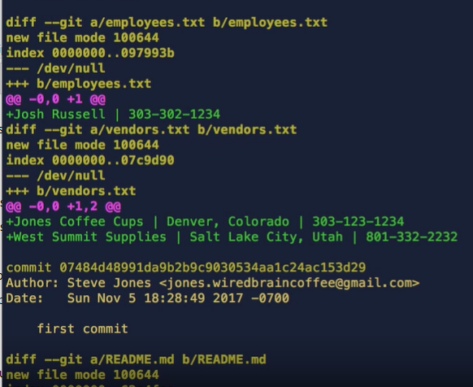

Now, if we want to get even more detail than this, we can type **git log ‑‑patch**, and then hit Enter. This command will give us the full diff of the exact changes in each file with each commit. This is similar to the results that we got back when using the git diff command. But instead of doing it on changes in our staging area, we can go back to any commit in our project's history using git log and see this detailed view. We can navigate these changes using the up and down arrow keys. And when finished, we can type Q for quit. Now again, there are so many options when viewing the commit log. We can search for author, date range, or even for certain commit messages. But for now, just know that we've only scratched the surface of what we can do when using git log.

**Commit Messages**

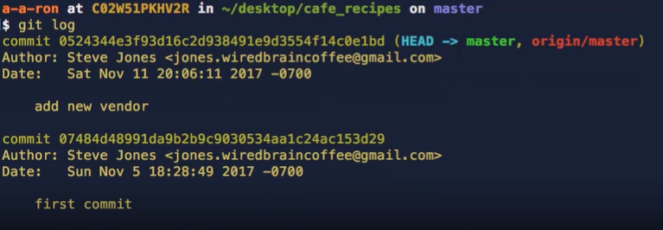

Now, let's run git log again, but without any parameters, and then hit Enter. We see the typical output response of git log with the commit SHA‑1 hash, Author, Date, and commit message. At first glance, it can be very difficult to know generally what was modified in each commit, if the commit message said something vague, or didn't make much sense. Now this may not be too much of a problem if you're working on the project by yourself. But as most working projects include other contributors, it's incredibly important to have meaningful commit messages so that others, as well as ourselves can understand the changes that are being made in that commit. For example, let's look at our first commit, the second in the list with the message of first commit. Now, this doesn't tell us anything that happened in this commit, except that it was our first commit. Now without looking further, we don't know which files were changed or what was changed in those files. This can make life very difficult if we needed to revert a commit that introduced a bug and we needed to find that specific commit or if we just need to review specific changes introduced in a commit. If the commit message isn't detailed enough, life for every contributor on the project can get pretty frustrating. So, for this reason, there are some general rules and guidelines when writing a commit message. Of course, these are just guidelines and can change depending on how the project is structured to be maintained. But nonetheless, these guidelines are followed in most cases. Chris Beams wrote a great blog post in 2014 about writing commit messages that outlined the general seven rules to a great commit message. We can find this blog post online, and we can even open it up in our default web browser from our command line by typing open **http://,** and then the URL, which **is chris.beams.io/posts/git‑commit.** Now there's a lot of really good information here supporting why good commit messages really matter, and Chris goes on to list the seven rules of a great commit message. **First, to separate the subject line from the body with a blank line**. Now up to this point our commit messages have only been a one‑line message written from our command line, and they didn't include a body. A lot of commits don't require both a subject and a body. Sometimes a single line is sufficient for the changes being made. For example, add a new ingredient to coconut oil coffee recipe. A change like this may not need a body in the commit message. **In addition, adding a commit message with the body is best done using a text editor to write the message rather than using the ‑m option in the command line.** Second, **limit the subject line to 50 characters.** The commit message should be short and to the point. If it's too long, it can be a tedious process to filter through lines and lines of messages to find exactly what you're looking for. And third, **capitalize the subject line**. And fourth, **do not end the subject line with a period**. Fifth, **use the imperative mood in the subject line**. Sixth, **wrap the body to about 72 characters.** Remember**, this is the body, not the subject line. And seventh, use the body to explain the what and why versus the how**. This one ties in a little bit with the first rule. If your commit needs an explanation on what is going on, **the body is used to explain the what and the why**. Remember, when you're writing a commit message, it's important to keep in mind that you're writing the message for other people to read and understand what is going on. The better the explanation, the easier it will be to navigate through the git log and the more transparent the log will be. So, let's jump back over to our command line and run git status again.

**Remove and Move Files**

At this point, we don't have anything yet to commit and our working tree is clean. Now, Steve has a bit of a problem. One of Steve's recipes, eggnog latte, has been getting some negative reviews and is the least‑ordered drink on his menu. Now, Steve wants to completely get rid of this recipe because no one is ordering it, and he's convinced he won't ever want to bring it back. So completely removing a file from his Git project is something that needs special consideration, especially if we've modified the file in our project, and its file versioning is being tracked by Git. Nonetheless, Steve wants it gone. So let's type ls in the command line to bring up the file. Now that we've verified that the eggnog latte file is present and currently being tracked by Git, Steve wants it removed from his project. So to remove a file in our project, we need to tell Git to stop tracking the file.

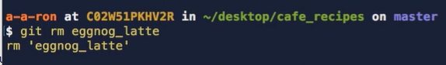

We can do this by using the **git rm command**. Since Steve wants to remove the eggnog latte recipe, let's type **git rm** eggnog_latte, and then hit Enter. We see that **Git responded with rm, and then our file, eggnog_latte, in quotes**. This is confirmation that we have staged this file's removal and Git has stopped tracking the file. We can then type **git status** to see our project's current state.

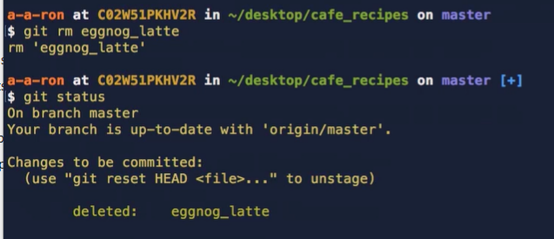

We see that our eggnog_latte file is now showing as a deleted file in our staging area, and the next time Steve commits, this file will no longer be tracked by Git and it will be removed from our project. We can also type ls to see the updated list of files under our project. Notice that the eggnog_latte file is no longer showing in our list. This is exactly what Steve wanted. But he also wants to untrack the irish_coffee file from Git but not remove the file from the project. Like we did with the eggnog_latte file, he wants to keep the file around but not have Git track it for nw.

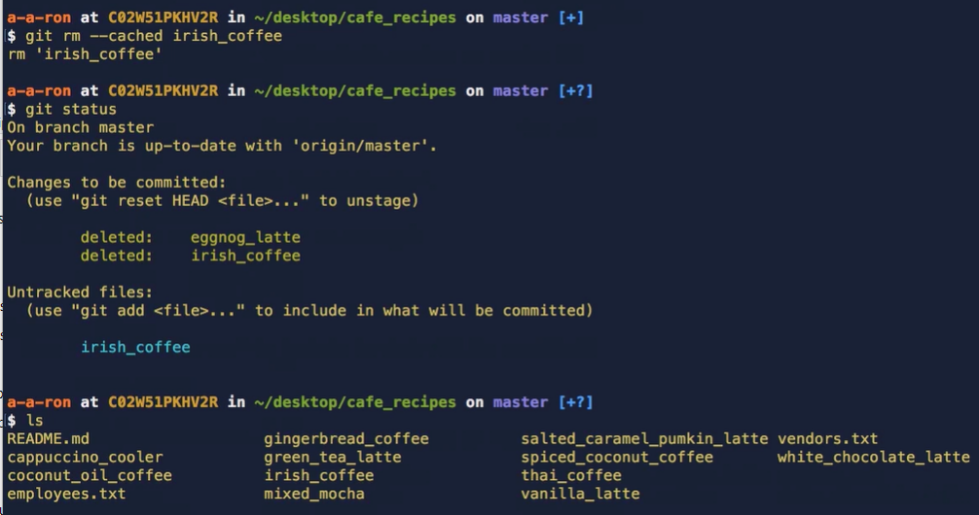

We can do this by typing **git rm ‑‑cached**, and then the file name, irish_coffee. We see a similar Git response saying that the irish_coffee recipe was removed, but let's type git status to get a better picture of what was changed. We now see that the irish_coffee file is under the untracked files. We can also confirm this by typing the ls command to see the list of our files. Notice that the irish_coffee file is still present. Now, on a similar note, Steve wants to rename his README.md file, but he isn't sure how to do it by using Git.

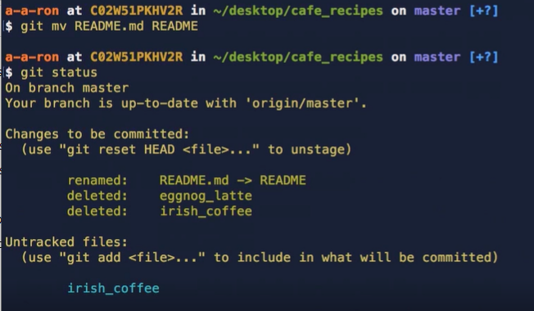

Now, we can do this by typing **git mv**, instead of rm, and then the file name that exists, followed by the desired file name. So in Steve's case, he wants the README.md file renamed to just README. We can change this by typing **git mv README.md, space, README.** if we now run git status, we see that in our staging area the file is now showing as renamed and ready to be committed into our next commit snapshot.

**Introduction to Branches**

At this point, we have some files in our staging area waiting to be committed into our next snapshot. But Steve has some new recipe ideas he wants to mess around with, ones that he doesn't know if he wants to incorporate yet into his main list of recipes, but he wants Git to track the progress of these changes. Now, Steve can make these changes right on his master branch, and Git would track those. But his staging area and working directory will messy with all sorts of different changes. That can pretty confusing. This is where we introduce one of the best things about Git, branches. And a really great way to see the power of branches is to visit a visualizing tool created by some developers at GitHub. We can open this URL using our command line by typing **open http://git‑school.github.io/visualizing‑git**. So, let's jump over to this URL to see the power of branches in action. Here, we see a green dot that represents our project's master branch. We can see this by the labels given in this visual. In the bottom‑left text, it says enter **git command**. We can type some Git commands here to visualize how branching works. Now, in Steve's project, we've made some commits onto the master branch. So, let's add some commits to the visual by typing git commit a few times. We see that our HEAD, which is where we are currently pointing at on our project, is moving along with master. This makes sense. We haven't done anything yet to divert any work that is being done, and this is what Steve has been doing on his project. Everything has been done on the master branch up to this point. Now a branch in Git is simply a lightweight, movable pointer to a commit made in a project. A commit needs to be made on a branch, but you have full flexibility on telling Git what branch to make that commit on.

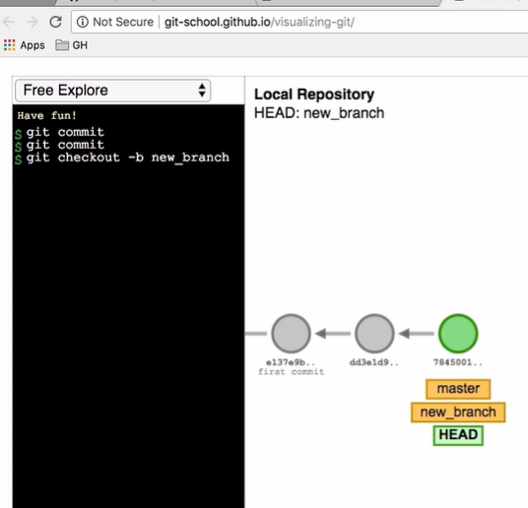

Let's create a new branch off of the master branch. We can do this by typing **git checkout ‑b** and **then the name of our branch**. For now, let's just call it **new_branch**. Notice now that a new pointer has been created called new_branch. Let's dissect the command we just ran. The git checkout command lets you check out to a different branch, and the ‑b option is telling Git that we want to create a new branch and then check out to it. Notice that our new_branch, master, and HEAD all point to the same commit in our project, but that our HEAD pointer is now under new_branch and no longer directly under master. This is because we have checked out to our new_branch, and we are no longer in our master branch. HEAD is just a pointer to our current state on the branch we are on. Let's now make a couple commits on our new branch. Notice that master stays behind, and our new branch moves along with the commits. We are making commits on the new_branch and no longer on master.

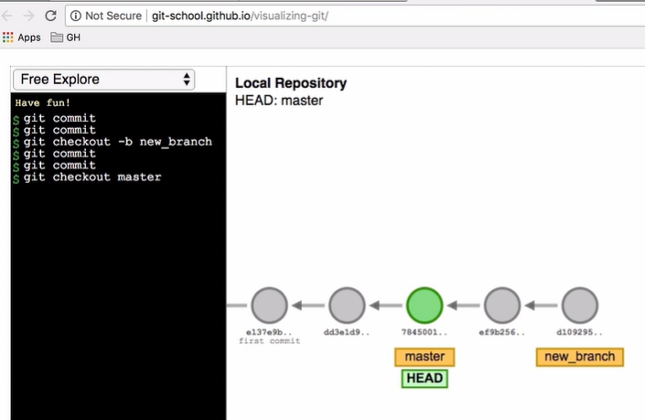

And we can check out back to our master branch by typing **git checkout master**. Notice that HEAD is now pointing back to the master branch because we are now checked out to the master branch. Notice that the other commits stay on our new_branch, even if we've checked out to a different branch. If you commit on a branch, those commits, unless explicitly changed, are linked to that branch.

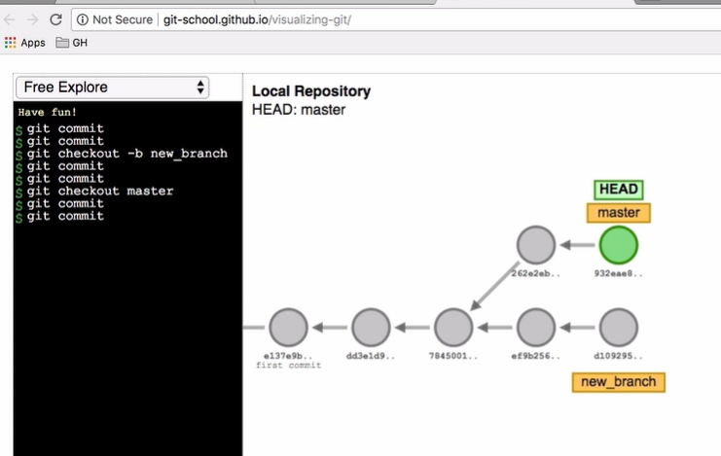

If we now want to make changes to the master branch, those changes will only be on the master branch. They will not be included in the new_branch. So, let's make a couple commits on master and see what happens. Notice how the work on our project has now diverted. The direction on our master branch is now slightly different than the work done on our new branch.

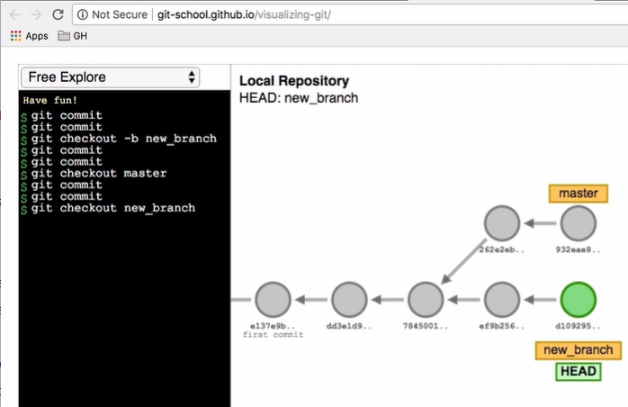

If we check out back to our new branch, we now see that our HEAD has moved back to that branch. If we make another commit, the work continues on that branch and that branch alone. The changes made on our new_branch won't affect anything on master. Branching off of master allows us to create a parallel environment where we can try out new ideas and make changes without affecting the master branch. And this is huge when trying out new ideas or working with multiple collaborators. Now, this only scratches the surface of what we can do with branching in Git. **Branching is a key concept when using Git, especially with working with multiple collaborators**. Now that we have the basic understanding on branching, let's jump back over to our terminal window and create a branch off of master similar to what we did here and then make some commits on our new_branch.

**Working with Branches**

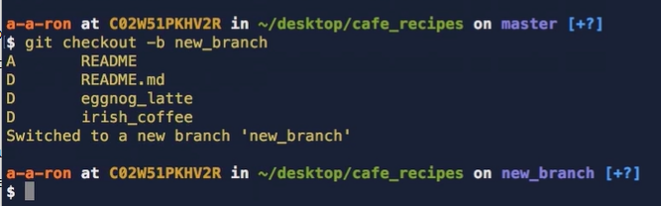

To create a branch off of master, let's type **git checkout ‑b new_branch**. Remember, this creates our new branch and checks out to it at the same time. If we just wanted to create a branch, but not check out to it at that moment, we can just type git branch and then the name of our branch. Let's now run git status. We see our renamed file and deleted eggnot_latte file as changes to be committed. Now, we made these changes on our master branch. Why are they showing up in our new branch? In the Git visualize tool that we just used, it showed us that the commit state on the branch that you made them. Well, this is correct. When we removed and renamed these files on our master branch, they remained in our staging area. We didn't commit these changes yet to a branch. And since we created a new branch off of master at this point in time, the changes in the staging area remained. So let's commit these changes to our new branch. **If you're ever unsure which branch you are checked out to, running git status will let you know.** Here, we see that Git tells us we are on branch new_branch. Since these changes are already in our staging area, we don't need to add them to be committed by running git add. Let's commit them as we've done before.

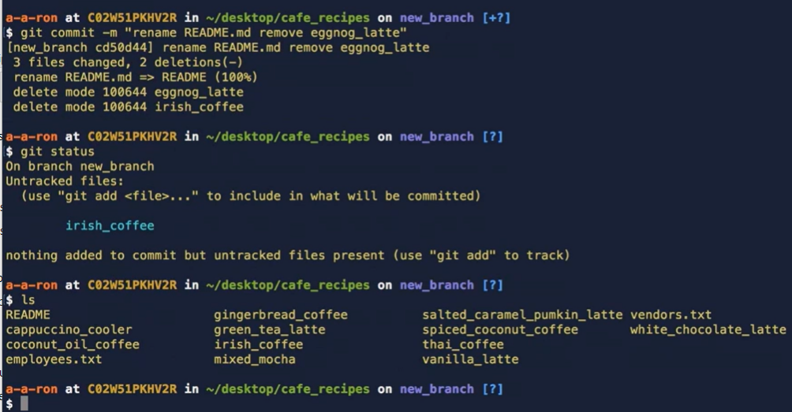

We type **git commit ‑m and then our commit message. Rename README.md and remove eggnog_latte.** Git now responds back with information on what was committed. We see that the README.md file we renamed and the eggnog_latte file was deleted. Running git status lets us see that we now have nothing to commit. But wait, we still have that irish_coffee file as an untracked file. But remember, this is all only done on our new branch. These changes were not committed to our master branch. If we run the ls command, we see that our changes on this branch are present;

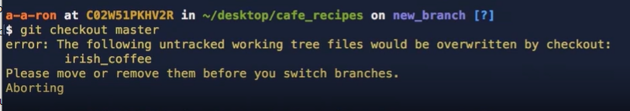

however, if we check out back to our master branch by typing git checkout master, we see an error saying, The following untracked working tree files would be overwritten by checkout. Please move or remove them before checkout. Now, since we untracked our file with **git rm ‑‑cached**, we deleted the version control cache, but did not remove or delete it from our file system. This is why it's still staying in an untracked state. When we try to check out to master or a different branch, Git is telling us that we need to do something with this file. Now, we can remove it, or we can add it back in to be tracked. But Steve doesn't quite want to get rid of this file, but he doesn't want to add it right now to be included in his local project.

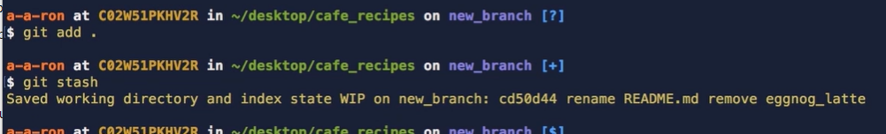

So Git provides us with an option to stash this change. We can do this by adding the file back in by typing **git add, and then dot**, and then using the stash command by typing git stash. We see that Git responded by saving our working directory in a work‑in‑progress state on our branch. We can use **git stash** to record a current state of the working directory and staging area, but want to go back to a clean working directory. Now that this change has been stashed, we type **git status** and see that our branch is clean, and nothing to commit, and nothing in our working directory. So where did this change go?

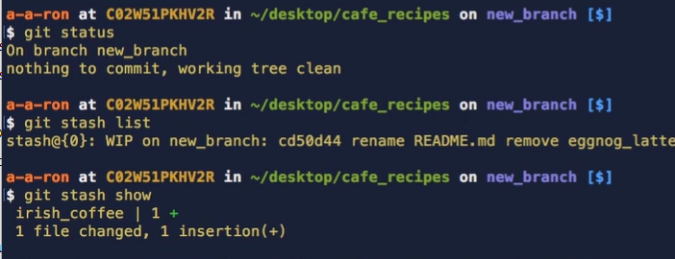

Now, if we type **git stash list**, Git provides us with a list of work‑in‑progress changes that we've stashed along with the branch and some commit data. We can also type **git stash show** to see a better detailed view of what file was stashed in a high‑level overview of the changes. Now, if Steve wanted to get this change out of stash, he simply needs to run git **stash pop**, and the change would be dropped back into his working directory. But since we don't want to do that right now, we'll just leave it in our stash for the moment.

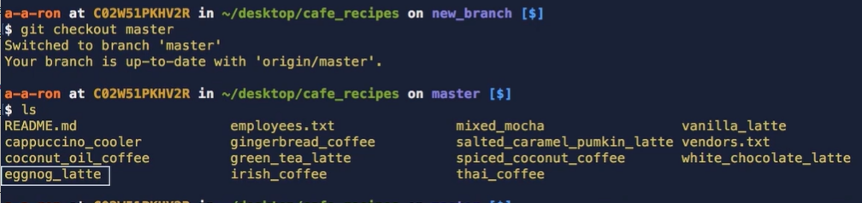

Let's now check out back to our master branch with **git checkout master** and then run the **ls command again**. We see that the README.md file is not renamed and the eggnog_latte file is still present. Now that we're on our master branch, let's create a new file named cold_brew by typing **touch cold_brew**, and then we can open it up in our Atom text editor by typing **atom, space, dot.** In our cold_brew file, let's add some content text, Placeholder for adding a new cold brew recipe. Let's save the file and return back to our terminal window. Let's now run **git add cold_brew** and **commit our changes by typing git commit ‑m and then our commit message, add cold brew placeholder file.** Now, running git status shows us that our local master branch is ahead of origin/master by 1 commit, and this is true because there our other commit was done on our new branch and not master. Let's return back to our git visualization tool to see what we've done.

**Merge**

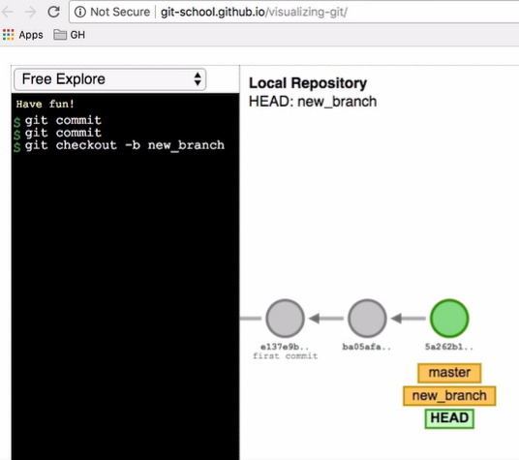

We then returned back to our master branch with git checkout master and created a newcold_brew file with some placeholder content.

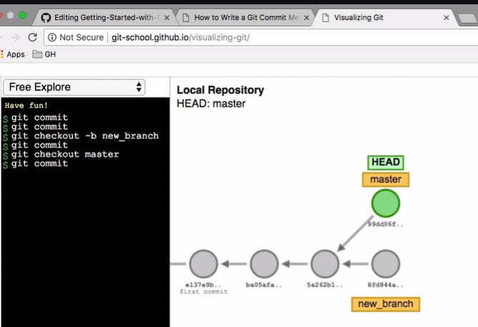

So let's represent this change on master with a commit. Notice that our project commit history has diverted. This is perfectly okay. Remember, branching lets you work on content without affecting the master branch, sort of like working in a test sandbox environment. And this is where we left off in our terminal command prompt. But what if we now want to incorporate the changes from our new branch into master? Well, this is a pretty common step. It wouldn't make much sense to create a separate branch if we never intended to incorporate those changes back into our production‑ready master branch.

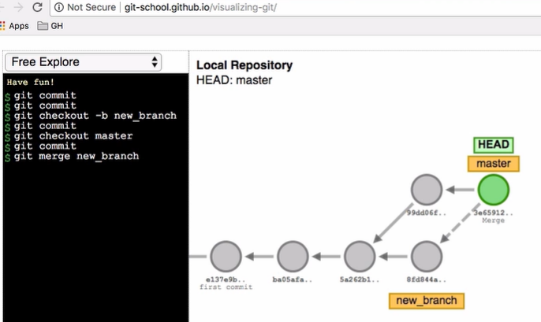

**Merging a branch into another branch is a key concept with branching and really the purpose of creating a branch**. Since we want to merge our changes into the master branch and we're already checked out to master, we can type **git merge and then the name of the branch we want to merge into**. So, in our case, we want to merge new branch into the master branch. So, let's do this. We now see that our head is still on master, but a new merge commit was created that is pointing to both branch paths. Our local master branch now has the changes that were made in our new branch.

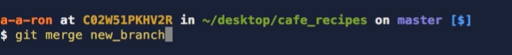

terminal window: Now, we're currently already checked out to master, so let's merge our new branch into master by typing **git merge new_branch**.

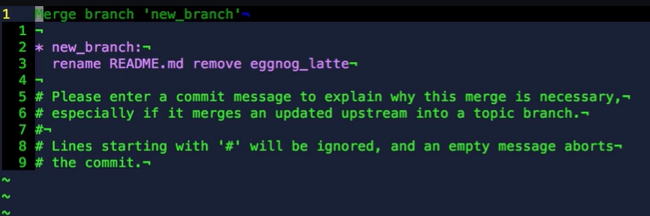

This brings up a tool called **Vim** where we need **to add our merge commit message, similar to a regular commit**. Now we won't be going over Vim in detail, but we can add our message by typing I to enter the interactive mode and then writing our merge commit message, which in our case, we'll just leave it as it already is. **And then when done, hitting the escape key, followed by :wq. The w saves our changes, and the q quits Vim.** We can see that the changes from the new_branch have now been added to our master branch. 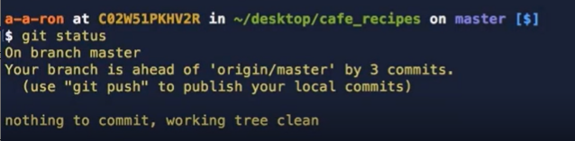

If we run **git status**, we now see that our local master branch is ahead of origin master by three commits. One commit was on our new branch, another was a direct commit on master, and the last commit was the merge commit to merge the new branch into the master branch.

**Reset**

Now, at this point, Steve could push his changes up to the origin master on GitHub, and it would include these three commits. His origin master and local master would then be in sync again with each other. But before we do so, what if we didn't want one of these commits or all of these commits anymore? Now that we've merged these commits into our local master, how can we reset some or all of these already committed changes or change the history of it? Well, this is a common enough situation that Git has a command just for this, and it's called **git reset**. Git reset allows us to move commits from history back into our working or staging area. It can also be used to throw changes away. Now, **this can be a destructive command, so careful consideration is highly recommended when using reset**. Since we're changing our Git history with reset, it's **best practice not to reset changes once we've pushed our commits to a remote origin where other collaborators could have accessed the changes.** Now, there are three different options when using git reset that will decide what happens to the commits that you want to alter.

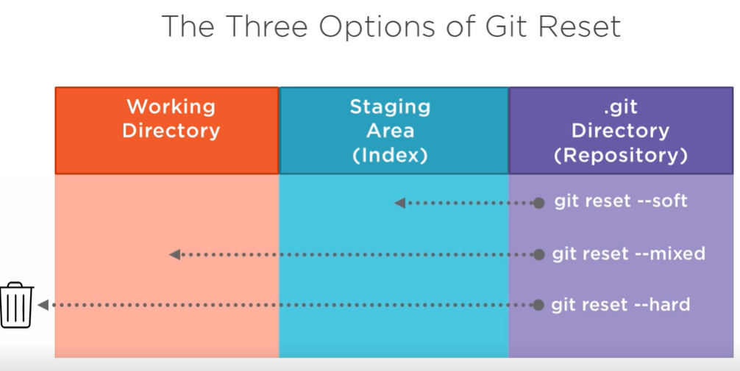

-The first is called **git reset ‑‑soft**. This reset command will move this specific commit or commits back into your staging area. This is helpful if you want to regroup these changes into different commits or add more changes before committing.

-The second option is **git reset ‑‑mixed** or just **git reset.** This is the default reset option if something else isn't already specified. This reset command is similar to ‑‑soft, but instead of moving the changes to the staging area, it moves the changes back to the working directory.

-And the last option is **git reset ‑‑hard**. Now this option moves the changes to the trash. This could be helpful if you've messed around with making changes and then you decided you didn't want to keep anything and just start over. But be careful when using this command. If you already have changes in your staging or working directory and you decide to run git reset ‑‑hard, those changes will also be deleted. So, let's jump back over to our terminal and see how this would work.

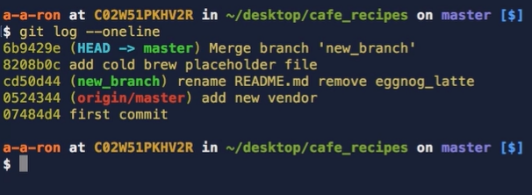

Now, let's run clear to bring our terminal back to the top. If we run **git log ‑‑oneline**, we'll see a list of commits that we've made in our project. We can see where our local head is pointing and where our origin master is pointing. Now this makes sense since our local master is ahead of origin by three commits. Our most recent commit is the merge commit when we merge the new_branch into our master branch. The next commit was on our master branch where we created the new cold brew file, and the commit before that was made on our new_branch where we committed the changes to rename the README file and remove the eggnog_latte file. The following commit is where 'origin/master' is currently pointing to. So, let's reset our master branch back to where our origin master is pointing.

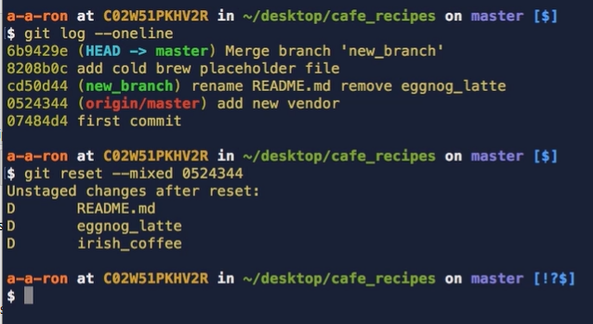

Let's use **git reset ‑‑mixed** or just git reset to move these changes back into our working directory. We can do this by typing git reset ‑‑mixed and then the commit that we want to move our head to, which again, is the one where the origin master is pointing to.

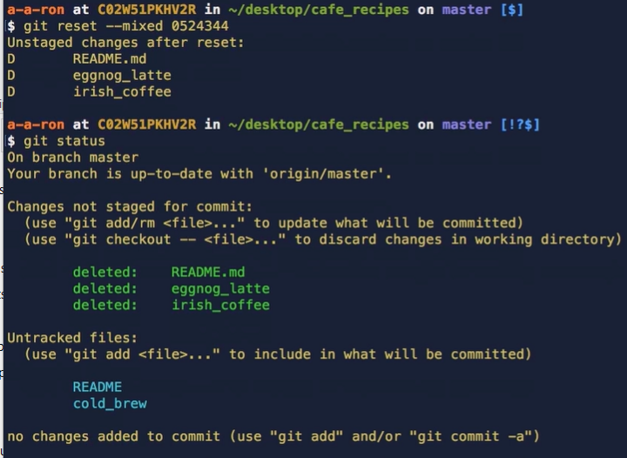

Let's now run **git status** to see what happened. We see that our changes from master, as well as the changes from our new_branch are now all showing in our working directory.

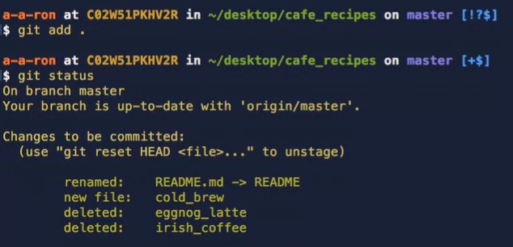

We can add these changes by typing **git add space dot**. If we now **run git status again**, we see that all changes made, ones originally made on our master branch, as well as the changes on our new_branch are now all together ready to be committed in our staging area. **Let's now commit these changes and add a commit message**.

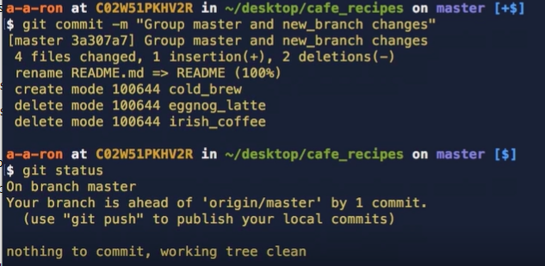

Now if we run git status, it now shows us that our master branch is now only one commit ahead of 'origin/master'/. Remember, the changes are all there when our local master was three commits ahead of 'origin/master', we've just changed our commit history to group these commits together into one commit. So, let's run clear to bring our command prompt back up to the top.

**Pull from Remote Origin**

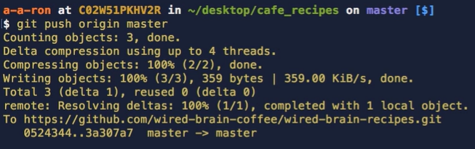

Let's now push our local master branch to origin master by typing **git push origin master**. Our origin master is now up to date with the changes we've made locally. Nice. Now that Steve's made the changes he wants and has pushed them up to origin master on GitHub, the next thing he wants to do is to pull down those changes to his other computers so that he can work on this project using his work and personal computers. We can do this by returning back to Steve's GitHub profile where Steve's repository is located. If we navigate to the Repositories tab and click on Steve's wired‑brain‑recipes project, we see a list of files and content inside of the project. In order for Steve to **clone this repository** down to another computer, you can click on the green **Clone or download** drop‑down menu button located toward the top right of the page. We can copy this HTTPS link by clicking on the Copy to clipboard icon next to the web URL. Now that we've copied the URL, we can open up the command prompt to clone the project down. So, let's jump back over one last time to our command prompt. Now, Steve can clone down this project to his other computer simply by navigating to the directory he wants to store the project in and then cloning the project into that directory.

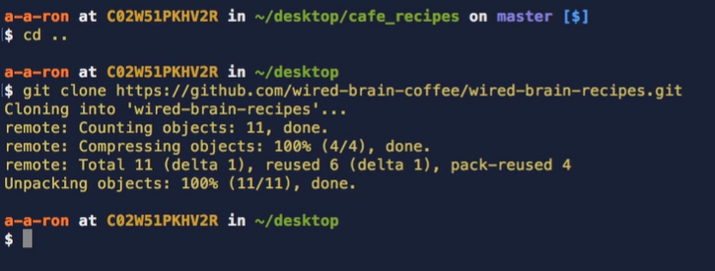

So let's navigate out of our cafe_recipes folder by typing **cd ..** to go back one directory. Steve can now clone down his repository by typing **git clone and then the URL that we copied.** We see that Git has cloned the wired‑brain‑recipes project into the same directory name. So let's cd into that new directory by typing cd wired‑brain‑recipes. We can now type git status to see that we are up to date with the origin master and then typing the ls command shows us the full list of files in our project that were pulled down from origin master. Now, Steve can follow these same simple steps to clone down his project to his other computers that he needs to to work on this project.

**Summary**

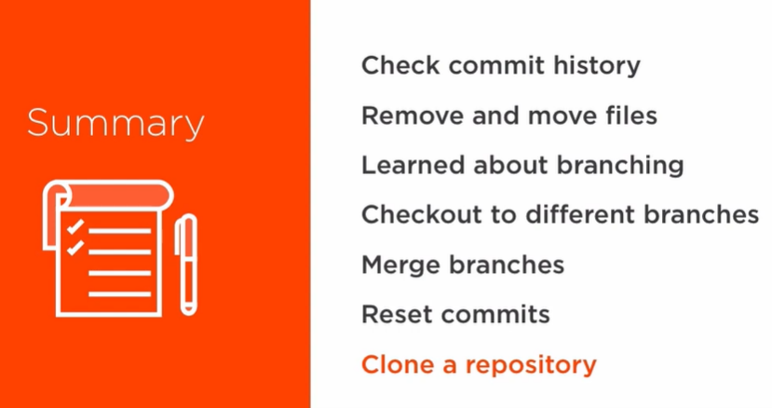

In summary, we've learned how to check our commit history by using git log and the different options we can use with **git diff**. We also learned how to remove and move files around in our project by using **git rm and git mv**. We then jumped into the core concept of branches and learned how using branches can be useful in a workflow. We learned how to create a branch by using **git checkout ‑b** to check out to our newly created branch or just git branch to create a new branch. We learned how to move around to different branches with checkout and then learned how to merge branches together to incorporate the changes made on one branch into another branch with **git merge**. We learned how to reset committed changes with **git reset ‑‑soft, git reset ‑‑mixed, and git reset ‑‑hard**. And lastly, we learned how to clone down a repository from GitHub so that we can work on our project from multiple computers by using **git clone and then the URL of our repository** found on GitHub.